Accident Detection & Alert System
ABSTRACT
Road accidents caused by drunk driving are a major safety concern worldwide. This project proposes an Alcohol Detection System with Motor Ignition Control, integrated with GPS location tracking, GSM-based alerting, and voice announcement using an APR voice module. The system detects alcohol presence in the driver’s breath before and during vehicle operation. If alcohol concentration exceeds a predefined threshold, the system automatically disables the motor ignition, plays a voice warning message, and sends the vehicle’s live location via SMS to a predefined contact such as police or a vehicle owner.
The system is built around an Arduino microcontroller, making it cost-effective, reliable, and suitable for real-time deployment. This project significantly enhances road safety by preventing intoxicated driving and enabling rapid response through location tracking.
Features:

- Remote communication using GSM modem.
- Sends location in the form of latitude and longitude.
- Reliable for remote tracking

PROJECT OBJECTIVES
- To detect alcohol presence in the driver’s breath accurately.
- To prevent vehicle ignition when alcohol is detected.
- To track the real-time location of the vehicle using GPS.
- To send alert messages with location details via GSM.
- To provide voice warnings using an APR voice announcement module.
- To reduce road accidents caused by drunk driving.
- To develop a reliable and low-cost vehicle safety system.

EXISTING SYSTEM
In the existing system:
- Traffic enforcement mainly relies on manual breath analyzers.
- Alcohol detection is done only during checkpoints.
- No automatic engine control mechanism is available.
- No real-time tracking or alert system exists.
- Accidents often occur before authorities can intervene.

Limitations of Existing System
- Requires human intervention
- Not continuous monitoring
- No ignition control
- No alert or tracking mechanism
- Delayed response in emergencies

INTRODUCTION

Nowadays, the rate of accidents has increased rapidly. Due to employment, the usage of vehicles like cars, bikes have increased, because of this reason the accidents can happen due to over speed. People are going under risk because of their over speed, due to unavailability of advanced techniques, the rate of accidents can’t be decreased. To reduce the accident rate in the country this paper introduces a solution. Automatic accident detection and alert systems are introduced. The main objective is to control the accidents by sending a message to the registered mobile, hospital and police station using wireless communications techniques. When an accident occurs in a city or any place, the message is sent to the registered mobile through GSM module in less time. Arduino is the heart of the system which helps in transferring the message to different devices in the system. Vibration sensor will be activated when the accident occurs and the information is transferred to the registered number through the GSM module. The GPS system will help in finding the location of the accident spot. The proposed system will check whether an accident has occurred and notify nearest medical centers and registered mobile numbers about the place of accident using GSM and GPS modules. The location can be sent through a tracking system to cover the geographical coordinates over the area. The accident can be detected by a vibration sensor which is used as a major module in the system
In the face of increasing road congestion and the critical need for prompt ambulance response during emergencies, a novel traffic control system has been proposed. This system aims to minimize ambulance delays caused by traffic signals, ensuring that ambulances can pass through all intersections without waiting.
In addition to addressing traffic-related delays, there is a growing concern about the rising rate of accidents, primarily attributed to speeding vehicles. To combat this issue, an automatic accident detection and alert system has been introduced, leveraging wireless communication technology. This system detects accidents using vibration sensors, relays the information via IOT modules, and provides accurate accident location data through GPS modules. The goal is to reduce accident-related fatalities and improve emergency response times.

CHAPTER 2: EMBEDDED SYSTEMS
2.1 Embedded Systems:
An embedded system is a computer system designed to perform one or a few dedicated functions often with real-time computing constraints. It is embedded as part of a complete device often including hardware and mechanical parts. By contrast, a general-purpose computer, such as a personal computer (PC), is designed to be flexible and to meet a wide range of end-user needs. Embedded systems control many devices in common use today.
Embedded systems are controlled by one or more main processing cores that are typically either microcontrollers or digital signal processors (DSP). The key characteristic, however, is being dedicated to handle a particular task, which may require very powerful processors. For example, air traffic control systems may usefully be viewed as embedded, even though they involve mainframe computers and dedicated regional and national networks between airports and radar sites. (Each radar probably includes one or more embedded systems of its own.)
Since the embedded system is dedicated to specific tasks, design engineers can optimize it to reduce the size and cost of the product and increase the reliability and performance. Some embedded systems are mass-produced, benefiting from economies of scale.
Physically embedded systems range from portable devices such as digital watches and MP3 players, to large stationary installations like traffic lights, factory controllers, or the systems controlling nuclear power plants. Complexity varies from low, with a single microcontroller chip, to very high with multiple units, peripherals and networks mounted inside a large chassis or enclosure.
In general, "embedded system" is not a strictly definable term, as most systems have some element of extensibility or programmability. For example, handheld computers share some elements with embedded systems such as the operating systems and microprocessors which power them, but they allow different applications to be loaded and peripherals to be connected. Moreover, even systems which don't expose programmability as a primary feature generally need to support software updates. On a continuum from "general purpose" to "embedded", large application systems will have subcomponents at most points even if the system as a whole is "designed to perform one or a few dedicated functions", and is thus appropriate to call "embedded". A modern example of embedded system is shown in fig: 2.1.
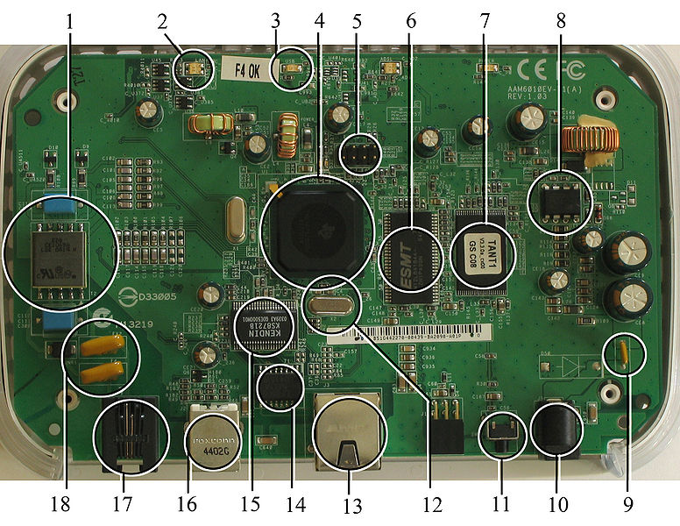
Fig 2.1:A modern example of embedded system
Labeled parts include microprocessor (4), RAM (6), flash memory (7).Embedded systems programming is not like normal PC programming. In many ways, programming for an embedded system is like programming PC 15 years ago. The hardware for the system is usually chosen to make the device as cheap as possible. Spending an extra dollar a unit in order to make things easier to program can cost millions. Hiring a programmer for an extra month is cheap in comparison. This means the programmer must make do with slow processors and low memory, while at the same time battling a need for efficiency not seen in most PC applications. Below is a list of issues specific to the embedded field.
2.1.1 History:
In the earliest years of computers in the 1930–40s, computers were sometimes dedicated to a single task, but were far too large and expensive for most kinds of tasks performed by embedded computers of today. Over time however, the concept of programmable controllersevolved from traditional electromechanical sequencers, via solid state devices, to the use of computer technology.
One of the first recognizably modern embedded systems was the Apollo Guidance Computer, developed by Charles Stark Draper at the MIT Instrumentation Laboratory. At the project's inception, the Apollo guidance computer was considered the riskiest item in the Apollo project as it employed the then newly developed monolithic integrated circuits to reduce the size and weight. An early mass-produced embedded system was the Autonetics D-17 guidance computer for the Minuteman missile, released in 1961. It was built from transistor logic and had a hard disk for main memory. When the Minuteman II went into production in 1966, the D-17 was replaced with a new computer that was the first high-volume use of integrated circuits.
2.1.2 Tools:
Embedded development makes up a small fraction of total programming. There's also a large number of embedded architectures, unlike the PC world where 1 instruction set rules, and the UNIX world where there's only 3 or 4 major ones. This means that the tools are more expensive. It also means that they're lowering featured, and less developed. On a major embedded project, at some point you will almost always find a compiler bug of some sort.

Debugging tools are another issue. Since you can't always run general programs on your embedded processor, you can't always run a debugger on it. This makes fixing your program difficult. Special hardware such as JTAG ports can overcome this issue in part. However, if you stop on a breakpoint when your system is controlling real world hardware (such as a motor), permanent equipment damage can occur. As a result, people doing embedded programming quickly become masters at using serial IO channels and error message style debugging.

2.1.3 Resources:
To save costs, embedded systems frequently have the cheapest processors that can do the job. This means your programs need to be written as efficiently as possible. When dealing with large data sets, issues like memory cache misses that never matter in PC programming can hurt you. Luckily, this won't happen too often- use reasonably efficient algorithms to start, and optimize only when necessary. Of course, normal profilers won't work well, due to the same reason debuggers don't work well.
Memory is also an issue. For the same cost savings reasons, embedded systems usually have the least memory they can get away with. That means their algorithms must be memory efficient (unlike in PC programs, you will frequently sacrifice processor time for memory, rather than the reverse). It also means you can't afford to leak memory. Embedded applications generally use deterministic memory techniques and avoid the default "new" and "malloc" functions, so that leaks can be found and eliminated more easily. Other resources programmers expect may not even exist. For example, most embedded processors do not have hardware FPUs (Floating-Point Processing Unit). These resources either need to be emulated in software, or avoided altogether.

2.1.4 Real Time Issues:
Embedded systems frequently control hardware, and must be able to respond to them in real time. Failure to do so could cause inaccuracy in measurements, or even damage hardware such as motors. This is made even more difficult by the lack of resources available. Almost all embedded systems need to be able to prioritize some tasks over others, and to be able to put off/skip low priority tasks such as UI in favor of high priority tasks like hardware control.
2.2 Need For Embedded Systems:
The uses of embedded systems are virtually limitless, because every day new products are introduced to the market that utilizes embedded computers in novel ways. In recent years, hardware such as microprocessors, microcontrollers, and FPGA chips have become much cheaper. So when implementing a new form of control, it's wiser to just buy the generic chip and write your own custom software for it. Producing a custom-made chip to handle a particular task or set of tasks costs far more time and money. Many embedded computers even come with extensive libraries, so that "writing your own software" becomes a very trivial task indeed. From an implementation viewpoint, there is a major difference between a computer and an embedded system. Embedded systems are often required to provide Real-Time response. The main elements that make embedded systems unique are its reliability and ease in debugging.

2.2.1 Debugging:
Embedded debugging may be performed at different levels, depending on the facilities available. From simplest to most sophisticate they can be roughly grouped into the following areas:
- Interactive resident debugging, using the simple shell provided by the embedded operating system (e.g. Forth and Basic)
- External debugging using logging or serial port output to trace operation using either a monitor in flash or using a debug server like the Remedy Debugger which even works for heterogeneous multi core systems.
- An in-circuit debugger (ICD), a hardware device that connects to the microprocessor via a JTAG or Nexus interface. This allows the operation of the microprocessor to be controlled externally, but is typically restricted to specific debugging capabilities in the processor.
- An in-circuit emulator replaces the microprocessor with a simulated equivalent, providing full control over all aspects of the microprocessor.
- A complete emulator provides a simulation of all aspects of the hardware, allowing all of it to be controlled and modified and allowing debugging on a normal PC.
- Unless restricted to external debugging, the programmer can typically load and run software through the tools, view the code running in the processor, and start or stop its operation. The view of the code may be as assembly code or source-code.

Because an embedded system is often composed of a wide variety of elements, the debugging strategy may vary. For instance, debugging a software(and microprocessor) centric embedded system is different from debugging an embedded system where most of the processing is performed by peripherals (DSP, FPGA, co-processor). An increasing number of embedded systems today use more than one single processor core. A common problem with multi-core development is the proper synchronization of software execution. In such a case, the embedded system design may wish to check the data traffic on the busses between the processor cores, which requires very low-level debugging, at signal/bus level, with a logic analyzer, for instance.

2.2.2 Reliability:
Embedded systems often reside in machines that are expected to run continuously for years without errors and in some cases recover by them if an error occurs. Therefore the software is usually developed and tested more carefully than that for personal computers, and unreliable mechanical moving parts such as disk drives, switches or buttons are avoided.
Specific reliability issues may include:
- The system cannot safely be shut down for repair, or it is too inaccessible to repair. Examples include space systems, undersea cables, navigational beacons, bore-hole systems, and automobiles.
- The system must be kept running for safety reasons. "Limp modes" are less tolerable. Often backup s are selected by an operator. Examples include aircraft navigation, reactor control systems, safety-critical chemical factory controls, train signals, engines on single-engine aircraft.
- The system will lose large amounts of money when shut down: Telephone switches, factory controls, bridge and elevator controls, funds transfer and market making, automated sales and service.

A variety of techniques are used, sometimes in combination, to recover from errors—both software bugs such as memory leaks, and also soft errors in the hardware:
- Watchdog timer that resets the computer unless the software periodically notifies the watchdog
- Subsystems with redundant spares that can be switched over to
- software "limp modes" that provide partial function
- Designing with a Trusted Computing Base (TCB) architecture[6] ensures a highly secure & reliable system environment
- An Embedded Hypervisor is able to provide secure encapsulation for any subsystem component, so that a compromised software component cannot interfere with other subsystems, or privileged-level system software. This encapsulation keeps faults from propagating from one subsystem to another, improving reliability. This may also allow a subsystem to be automatically shut down and restarted on fault detection.
- Immunity Aware Programming

2.3 Explanation of Embedded Systems:
2.3.1 Software Architecture:
There are several different types of software architecture in common use.
- Simple Control Loop:
In this design, the software simply has a loop. The loop calls subroutines, each of which manages a part of the hardware or software.
- Interrupt Controlled System:
Some embedded systems are predominantly interrupt controlled. This means that tasks performed by the system are triggered by different kinds of events. An interrupt could be generated for example by a timer in a predefined frequency, or by a serial port controller receiving a byte. These kinds of systems are used if event handlers need low latency and the event handlers are short and simple.
Usually these kinds of systems run a simple task in a main loop also, but this task is not very sensitive to unexpected delays. Sometimes the interrupt handler will add longer tasks to a queue structure. Later, after the interrupt handler has finished, these tasks are executed by the main loop. This method brings the system close to a multitasking kernel with discrete processes.
- Cooperative Multitasking:
A non-preemptive multitasking system is very similar to the simple control loop scheme, except that the loop is hidden in an API. The programmer defines a series of tasks, and each task gets its own environment to “run” in. When a task is idle, it calls an idle routine, usually called “pause”, “wait”, “yield”, “nop” (stands for no operation), etc.The advantages and disadvantages are very similar to the control loop, except that adding new software is easier, by simply writing a new task, or adding to the queue-interpreter.
- Primitive Multitasking:
In this type of system, a low-level piece of code switches between tasks or threads based on a timer (connected to an interrupt). This is the level at which the system is generally considered to have an "operating system" kernel. Depending on how much functionality is required, it introduces more or less of the complexities of managing multiple tasks running conceptually in parallel.
As any code can potentially damage the data of another task (except in larger systems using an MMU) programs must be carefully designed and tested, and access to shared data must be controlled by some synchronization strategy, such as message queues, semaphores or a non-blocking synchronization scheme.
Because of these complexities, it is common for organizations to buy a real-time operating system, allowing the application programmers to concentrate on device functionality rather than operating system services, at least for large systems; smaller systems often cannot afford the overhead associated with a generic real time system, due to limitations regarding memory size, performance, and/or battery life.
- Microkernels And Exokernels:
A microkernel is a logical step up from a real-time OS. The usual arrangement is that the operating system kernel allocates memory and switches the CPU to different threads of execution. User mode processes implement major functions such as file systems, network interfaces, etc.
In general, microkernels succeed when the task switching and intertask communication is fast, and fail when they are slow. Exokernels communicate efficiently by normal subroutine calls. The hardware and all the software in the system are available to, and extensible by application programmers. Based on performance, functionality, requirement the embedded systems are divided into three categories:
2.3.2 Stand Alone Embedded System:
These systems takes the input in the form of electrical signals from transducers or commands from human beings such as pressing of a button etc.., process them and produces desired output. This entire process of taking input, processing it and giving output is done in standalone mode. Such embedded systems comes under stand alone embedded systems
Eg: microwave oven, air conditioner etc..
2.3.3 Real-time embedded systems:
Embedded systems which are used to perform a specific task or operation in a specific time period those systems are called as real-time embedded systems. There are two types of real-time embedded systems.
- Hard Real-time embedded systems:
These embedded systems follow an absolute dead line time period i.e.., if the tasking is not done in a particular time period then there is a cause of damage to the entire equipment.
Eg: consider a system in which we have to open a valve within 30 milliseconds. If this valve is not opened in 30 ms this may cause damage to the entire equipment. So in such cases we use embedded systems for doing automatic operations.
- Soft Real Time embedded systems:
Eg: Consider a TV remote control system, if the remote control takes a few milliseconds delay it will not cause damage either to the TV or to the remote control. These systems which will not cause damage when they are not operated at considerable time period those systems comes under soft real-time embedded systems.
2.3.4 Network communication embedded systems:
A wide range network interfacing communication is provided by using embedded systems.
Eg:
- Consider a web camera that is connected to the computer with internet can be used to spread communication like sending pictures, images, videos etc.., to another computer with internet connection throughout anywhere in the world.
- Consider a web camera that is connected at the door lock.
Whenever a person comes near the door, it captures the image of a person and sends to the desktop of your computer which is connected to internet. This gives an alerting message with image on to the desktop of your computer, and then you can open the door lock just by clicking the mouse. Fig: 2.2 show the network communications in embedded systems.
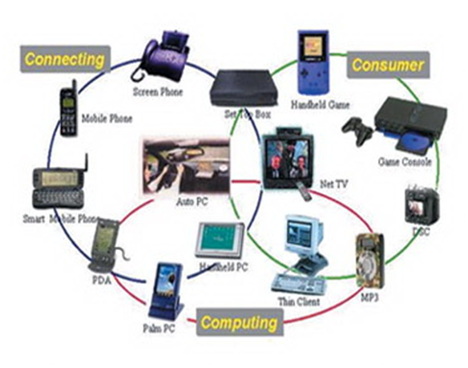
Fig 2.2: Network communication embedded systems

2.3.5 Different types of processing units:
The central processing unit (c.p.u) can be any one of the following microprocessor, microcontroller, digital signal processing.
- Among these Microcontroller is of low cost processor and one of the main advantage of microcontrollers is, the components such as memory, serial communication interfaces, analog to digital converters etc.., all these are built on a single chip. The numbers of external components that are connected to it are very less according to the application.
- Microprocessors are more powerful than microcontrollers. They are used in major applications with a number of tasking requirements. But the microprocessor requires many external components like memory, serial communication, hard disk, input output ports etc.., so the power consumption is also very high when compared to microcontrollers.
- Digital signal processing is used mainly for the applications that particularly involved with processing of signals
2.4 APPLICATIONS OF EMBEDDED SYSTEMS:
2.4.1 Consumer applications:
At home we use a number of embedded systems which include microwave oven, remote control, vcd players, dvd players, camera etc….
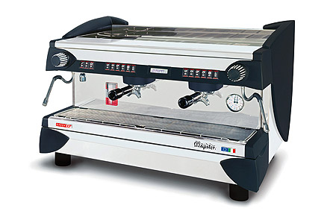
Fig2.3: Automatic coffee makes equipment

2.4.2 Office automation:
We use systems like fax machine, modem, printer etc…
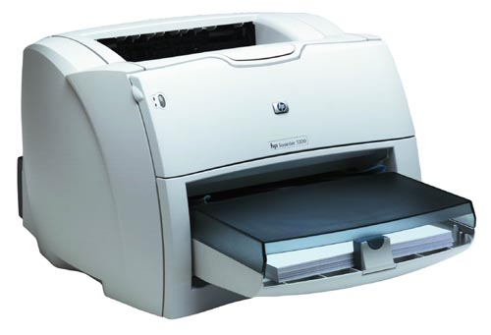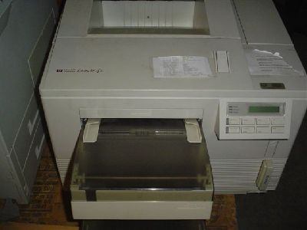
Fig2.4: Fax machine Fig2.5: Printing machine

2.4.3. Industrial automation:
Today a lot of industries are using embedded systems for process control. In industries we design the embedded systems to perform a specific operation like monitoring temperature, pressure, humidity ,voltage, current etc.., and basing on these monitored levels we do control other devices, we can send information to a centralized monitoring station.
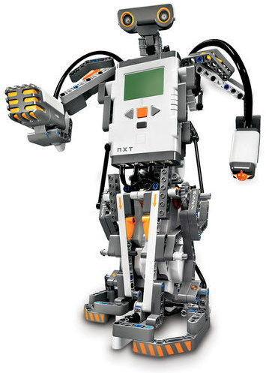
Fig2.6: Vehicle
In critical industries where human presence is avoided there we can use vehicles which are programmed to do a specific operation.

2.4.5 Computer networking:
Embedded systems are used as bridges routers etc..
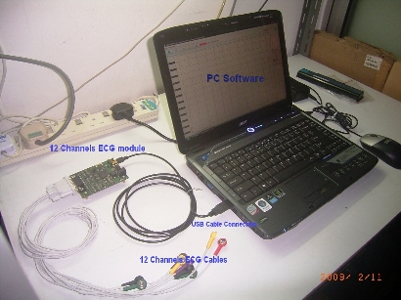
Fig2.7: Computer networking
2.4.6 Tele communications:
Cell phones, web cameras etc.
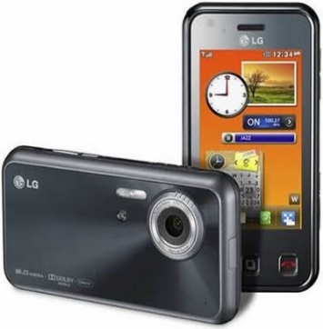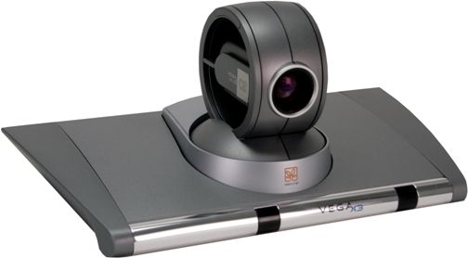
Fig2.8: Cell PhoneFig2.9: Web camera

CHAPTER-3
HARDWARE DESCRIPTION
In this chapter the block diagram of the project and design aspect of independent modules are considered. Block diagram is shown in fig: 3.1:
RPS
GSM AND GPS

ARDUINO
ATEMGA 328
16*2 LCD
ALCOHOL SENSOR

APR9600
SPEAKER
Relay

Dc motor
The Major Building blocks of this project are:
- Regulated Power Supply.
- Microcontroller.
- GPS Receiver.
- GSM modem.
- Reset.
- ALCOHOL sensor.
- Crystal oscillator.
- LED Indicators
- LCD display with driver.
- APR9600 VOICE MODULE WITH SPEAKER

3.3 REGULATED POWER SUPPLY:
3.3.1 Introduction:
Power supply is a supply of electrical power. A device or system that supplies electrical or other types of energy to an output load or group of loads is called a power supply unit or PSU. The term is most commonly applied to electrical energy supplies, less often to mechanical ones, and rarely to others.
A power supply may include a power distribution system as well as primary or secondary sources of energy such as
- Conversion of one form of electrical power to another desired form and voltage, tyarduinoally involving converting AC line voltage to a well-regulated lower-voltage DC for electronic devices. Low voltage, low power DC power supply units are commonly integrated with the devices they supply, such as computers and household electronics.
- Batteries.
- Chemical fuel cells and other forms of energy storage systems.
- Solar power.
- Generators or alternators.

3.3.2 Block Diagram:

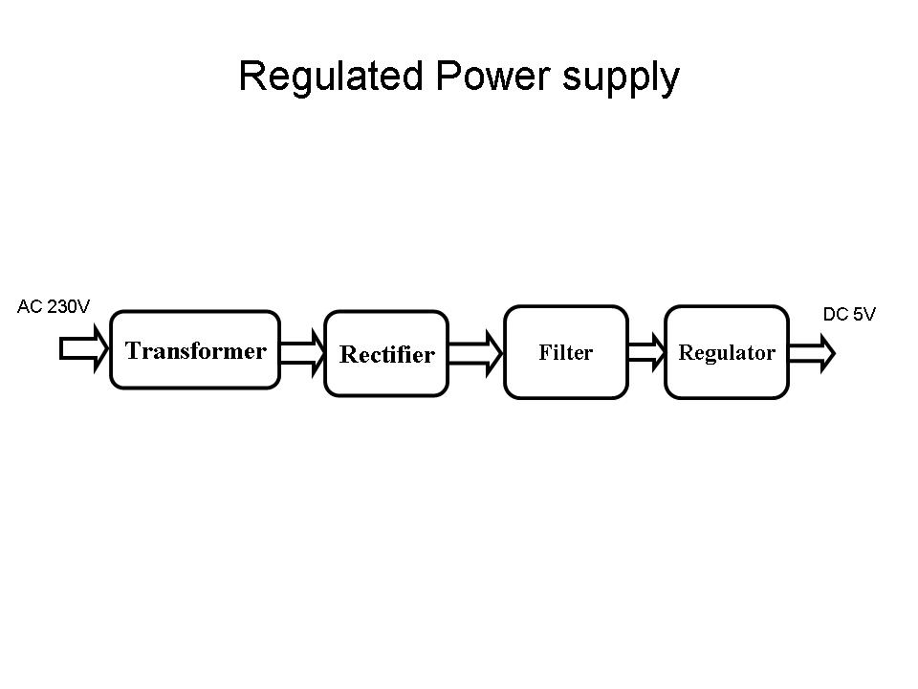
Fig 3.3.2 Regulated Power Supply
The basic circuit diagram of a regulated power supply (DC O/P) with led connected as load is shown below
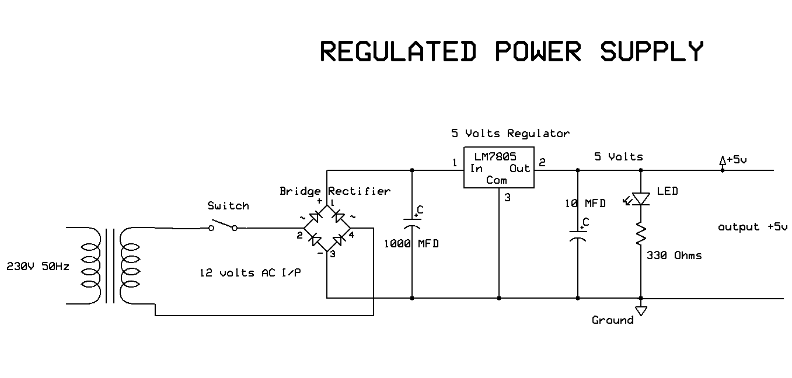
Fig 3.3.3 Circuit diagram of Regulated Power Supply with Led connection

The components mainly used in above figure are
- 230V AC MAINS
- TRANSFORMER
- BRIDGE RECTIFIER(DIODES)
- CAPACITOR
- VOLTAGE REGULATOR(IC 7805)
- RESISTOR
- LED(LIGHT EMITTING DIODE)

POWER SUPPLY DESIGN:

Input is 230 volts A.C
Transformation

Rectification
Filtration
Regulation

Output is 5 volts D.C

The detailed explanation of each and every block and component mentioned above is as follows:

- Transformation:
The process of transforming energy from one device to another is called transformation. For transforming energy we use transformers.

Transformers:
A transformer is a device that transfers electrical energy from one circuit to another through inductively coupled conductors without changing its frequency. A varying current in the first or primary winding creates a varying magnetic flux in the transformer's core, and thus a varying magnetic field through the secondary winding. This varying magnetic field induces a varying electromotive force (EMF) or "voltage" in the secondary winding. This effect is called mutual induction.
If a load is connected to the secondary, an electric current will flow in the secondary winding and electrical energy will be transferred from the primary circuit through the transformer to the load. This field is made up from lines of force and has the same shape as a bar magnet.
If the current is increased, the lines of force move outwards from the coil. If the current is reduced, the lines of force move inwards.
If another coil is placed adjacent to the first coil then, as the field moves out or in, the moving lines of force will "cut" the turns of the second coil. As it does this, a voltage is induced in the second coil. With the 50 Hz AC mains supply, this will happen 50 times a second. This is called MUTUAL INDUCTION and forms the basis of the transformer.
The input coil is called the PRIMARY WINDING; the output coil is the SECONDARY WINDING. Fig: 3.5 shows step-down transformer.
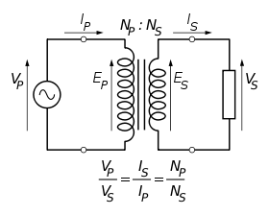
Fig 3.4: Step-Down Transformer
The voltage induced in the secondary is determined by the TURNS RATIO.
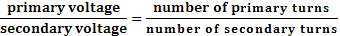
For example, if the secondary has half the primary turns; the secondary will have half the primary voltage.
Another example is if the primary has 5000 turns and the secondary has 500 turns, then the turn’s ratio is 10:1.
If the primary voltage is 240 volts then the secondary voltage will be x 10 smaller = 24 volts. Assuming a perfect transformer, the power provided by the primary must equal the power taken by a load on the secondary. If a 24-watt lamp is connected across a 24 volt secondary, then the primary must supply 24 watts.
To aid magnetic coupling between primary and secondary, the coils are wound on a metal CORE. Since the primary would induce power, called EDDY CURRENTS, into this core, the core is LAMINATED. This means that it is made up from metal sheets insulated from each other. Transformers to work at higher frequencies have an iron dust core or no core at all.
Note that the transformer only works on AC, which has a constantly changing current and moving field. DC has a steady current and therefore a steady field and there would be no induction.
Some transformers have an electrostatic screen between primary and secondary. This is to prevent some types of interference being fed from the equipment down into the mains supply, or in the other direction. Transformers are sometimes used for IMPEDANCE MATCHING.
We can use the transformers as step up or step down.
Step Up transformer:
In case of step up transformer, primary windings are every less compared to secondary winding.
Because of having more turns secondary winding accepts more energy, and it releases more voltage at the output side.

Step down transformer:
Incase of step down transformer, Primary winding induces more flux than the secondary winding, and secondary winding is having less number of turns because of that it accepts less number of flux, and releases less amount of voltage.
Battery power supply:
A battery is a type of linear power supply that offers benefits that traditional line-operated power supplies lack: mobility, portability and reliability. A battery consists of multiple electrochemical cells connected to provide the voltage desired. Fig: 3.6 shows Hi-Watt 9V battery

Fig 3.5: Hi-Watt 9V Battery
The most commonly used dry-cell battery is the carbon-zinc dry cell battery. Dry-cell batteries are made by stacking a carbon plate, a layer of electrolyte paste, and a zinc plate alternately until the desired total voltage is achieved. The most common dry-cell batteries have one of the following voltages: 1.5, 3, 6, 9, 22.5, 45, and 90. During the discharge of a carbon-zinc battery, the zinc metal is converted to a zinc salt in the electrolyte, and magnesium dioxide is reduced at the carbon electrode. These actions establish a voltage of approximately 1.5 V.
The lead-acid storage battery may be used. This battery is rechargeable; it consists of lead and lead/dioxide electrodes which are immersed in sulfuric acid. When fully charged, this type of battery has a 2.06-2.14 V potential (A 12 volt car battery uses 6 cells in series). During discharge, the lead is converted to lead sulfate and the sulfuric acid is converted to water. When the battery is charging, the lead sulfate is converted back to lead and lead dioxide A nickel-cadmium battery has become more popular in recent years. This battery cell is completely sealed and rechargeable. The electrolyte is not involved in the electrode reaction, making the voltage constant over the span of the batteries long service life. During the charging process, nickel oxide is oxidized to its higher oxidation state and cadmium oxide is reduced. The nickel-cadmium batteries have many benefits. They can be stored both charged and uncharged. They have a long service life, high current availabilities, constant voltage, and the ability to be recharged.
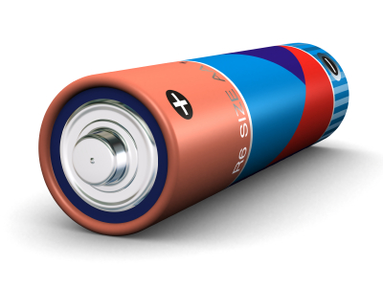
Fig 3.6: Pencil Battery of 1.5V
2. Rectification:
The process of converting an alternating current to a pulsating direct current is called as rectification. For rectification purpose we use rectifiers.
Rectifiers:
A rectifier is an electrical device that converts alternating current (AC) to direct current (DC), a process known as rectification. Rectifiers have many uses including as components of power supplies and as detectors of radio signals. Rectifiers may be made of solid-state diodes, vacuum tube diodes, mercury arc valves, and other components.
A device that it can perform the opposite function (converting DC to AC) is known as an inverter.
When only one diode is used to rectify AC (by blocking the negative or positive portion of the waveform), the difference between the term diode and the term rectifier is merely one of usage, i.e., the term rectifier describes a diode that is being used to convert AC to DC. Almost all rectifiers comprise a number of diodes in a specific arrangement for more efficiently converting AC to DC than is possible with only one diode. Before the development of silicon semiconductor rectifiers, vacuum tube diodes and copper (I) oxide or selenium rectifier stacks were used.
Bridge full wave rectifier:
The Bridge rectifier circuit is shown in fig:3.8, which converts an ac voltage to dc voltage using both half cycles of the input ac voltage. The Bridge rectifier circuit is shown in the figure. The circuit has four diodes connected to form a bridge. The ac input voltage is applied to the diagonally opposite ends of the bridge. The load resistance is connected between the other two ends of the bridge.
For the positive half cycle of the input ac voltage, diodes D1 and D3 conduct, whereas diodes D2 and D4 remain in the OFF state. The conducting diodes will be in series with the load resistance R_{L} and hence the load current flows through R_{L.}
For the negative half cycle of the input ac voltage, diodes D2 and D4 conduct whereas, D1 and D3 remain OFF. The conducting diodes D2 and D4 will be in series with the load resistance R_{L} and hence the current flows through R_{L} in the same direction as in the previous half cycle. Thus a bi-directional wave is converted into a unidirectional wave.

Input Output
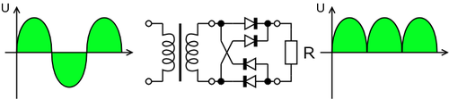

Fig 3.7: Bridge rectifier: a full-wave rectifier using 4 diodes

DB107:
Now -a -days Bridge rectifier is available in IC with a number of DB107. In our project we are using an IC in place of bridge rectifier. The arduinoture of DB 107 is shown below
Features:
- Good for automation insertion
- Surge overload rating - 30 amperes peak
- Ideal for printed circuit board
- Reliable low cost construction utilizing molded
- Glass passivated device
- Polarity symbols molded on body
- Mounting position: Any
- Weight: 1.0 gram
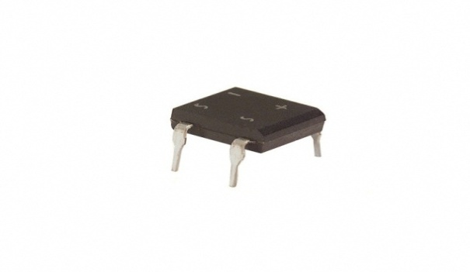
Fig 3.8: DB107
3. Filtration:
The process of converting a pulsating direct current to a pure direct current using filters is called as filtration.

Filters:
Electronic filters are electronic circuits, which perform signal-processing functions, specifically to remove unwanted frequency components from the signal, to enhance wanted ones.
Introduction to Capacitors:
The Capacitor or sometimes referred to as a Condenser is a passive device, and one which stores energy in the form of an electrostatic field which produces a potential (static voltage) across its plates. In its basic form a capacitor consists of two parallel conductive plates that are not connected but are electrically separated either by air or by an insulating material called the Dielectric. When a voltage is applied to these plates, a current flows charging up the plates with electrons giving one plate a positive charge and the other plate an equal and opposite negative charge. This flow of electrons to the plates is known as the Charging Current and continues to flow until the voltage across the plates (and hence the capacitor) is equal to the applied voltage Vcc. At this point the capacitor is said to be fully charged and this is illustrated below. The construction of capacitor and an electrolytic capacitor are shown in figures 3.10 and 3.11 respectively.
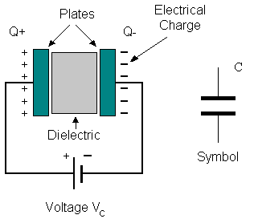
Fig 3.9:Construction Of a Capacitor Fig 3.10:Electrolytic Capaticor
Units of Capacitance:
Microfarad (μF) 1μF = 1/1,000,000 = 0.000001 = 10⁻⁶ F
Nanofarad (nF) 1nF = 1/1,000,000,000 = 0.000000001 = 10⁻⁹ F
Arduinoo farad (pF) 1pF = 1/1,000,000,000,000 = 0.000000000001 = 10⁻¹² F

Operation of Capacitor:
Think of water flowing through a pipe. If we imagine a capacitor as being a storage tank with an inlet and an outlet pipe, it is possible to show approximately how an electronic capacitor works.
First, let's consider the case of a "coupling capacitor" where the capacitor is used to connect a signal from one part of a circuit to another but without allowing any direct current to flow.
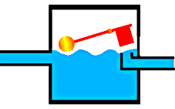 | If the current flow is alternating between zero and a maximum, our "storage tank" capacitor will allow the current waves to pass through.
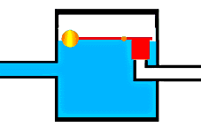 | However, if there is a steady current, only the initial short burst will flow until the "floating ball valve" closes and stops further flow.
So a coupling capacitor allows "alternating current" to pass through because the ball valve doesn't get a chance to close as the waves go up and down. However, a steady current quickly fills the tank so that all flow stops.
A capacitor will pass alternating current but (apart from an initial surge) it will not pass d.c.
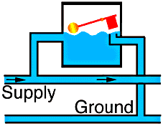 | Where a capacitor is used to decouple a circuit, the effect is to "smooth out ripples". Any ripples, waves or pulses of current are passed to ground while d.c. Flows smoothly.
4. Regulation:
The process of converting a varying voltage to a constant regulated voltage is called as regulation. For the process of regulation we use voltage regulators.
Voltage Regulator:
A voltage regulator (also called a ‘regulator’) with only three terminals appears to be a simple device, but it is in fact a very complex integrated circuit. It converts a varying input voltage into a constant ‘regulated’ output voltage. Voltage Regulators are available in a variety of outputs like 5V, 6V, 9V, 12V and 15V. The LM78XX series of voltage regulators are designed for positive input. For applications requiring negative input, the LM79XX series is used. Using a pair of ‘voltage-divider’ resistors can increase the output voltage of a regulator circuit.
It is not possible to obtain a voltage lower than the stated rating. You cannot use a 12V regulator to make a 5V power supply. Voltage regulators are very robust. These can withstand over-current draw due to short circuits and also over-heating. In both cases, the regulator will cut off before any damage occurs. The only way to destroy a regulator is to apply reverse voltage to its input. Reverse polarity destroys the regulator almost instantly. Fig: 3.12 shows voltage regulator.
Fig 3.11: Voltage Regulator

Resistors:
A resistor is a two-terminal electronic component that produces a voltage across its terminals that is proportional to the electric current passing through it in accordance with Ohm's law:
V = IR
Resistors are elements of electrical networks and electronic circuits and are ubiquitous in most electronic equipment. Practical resistors can be made of various compounds and films, as well as resistance wire (wire made of a high-resistivity alloy, such as nickel/chrome).
The primary characteristics of a resistor are the resistance, the tolerance, maximum working voltage and the power rating. Other characteristics include temperature coefficient, noise, and inductance. Less well-known is critical resistance, the value below which power dissipation limits the maximum permitted current flow, and above which the limit is applied voltage. Critical resistance is determined by the design, materials and dimensions of the resistor.
Resistors can be made to control the flow of current, to work as Voltage dividers, to dissipate power and it can shape electrical waves when used in combination of other components. Basic unit is ohms.
Theory of operation:

Ohm's law:

The behavior of an ideal resistor is dictated by the relationship specified in Ohm's law:
V = IR
Ohm's law states that the voltage (V) across a resistor is proportional to the current (I) through it where the constant of proportionality is the resistance (R).

Power dissipation:
The power dissipated by a resistor (or the equivalent resistance of a resistor network) is calculated using the following:
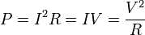
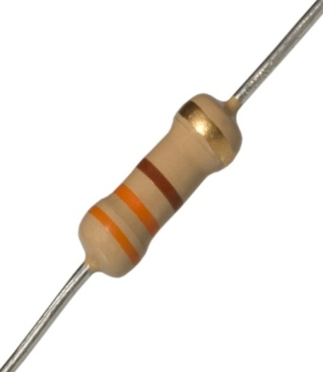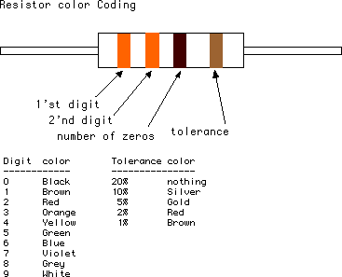
Fig 3.12: Resistor Fig 3.13: Color Bands In Resistor

3.4. LED:
A light-emitting diode (LED) is a semiconductor light source. LED’s are used as indicator lamps in many devices, and are increasingly used for lighting. Introduced as a practical electronic component in 1962, early LED’s emitted low-intensity red light, but modern versions are available across the visible, ultraviolet and infrared wavelengths, with very high brightness. The internal structure and parts of a led are shown in figures 3.15 and 3.16 respectively.
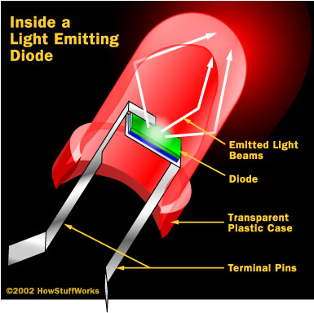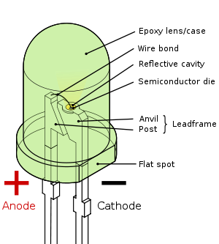
Fig 3.14: Inside a LED Fig 3.15: Parts of a LED

Working:
The structure of the LED light is completely different than that of the light bulb. Amazingly, the LED has a simple and strong structure. The light-emitting semiconductor material is what determines the LED's color. The LED is based on the semiconductor diode.
When a diode is forward biased (switched on), electrons are able to recombine with holes within the device, releasing energy in the form of photons. This effect is called electroluminescence and the color of the light (corresponding to the energy of the photon) is determined by the energy gap of the semiconductor. An LED is usually small in area (less than 1 mm²), and integrated optical components are used to shape its radiation pattern and assist in reflection. LED’s present many advantages over incandescent light sources including lower energy consumption, longer lifetime, improved robustness, smaller size, faster switching, and greater durability and reliability. However, they are relatively expensive and require more precise current and heat management than traditional light sources. Current LED products for general lighting are more expensive to buy than fluorescent lamp sources of comparable output. They also enjoy use in applications as diverse as replacements for traditional light sources in automotive lighting (particularly indicators) and in traffic signals. The compact size of LED’s has allowed new text and video displays and sensors to be developed, while their high switching rates are useful in advanced communications technology. The electrical symbol and polarities of led are shown in fig: 3.17.
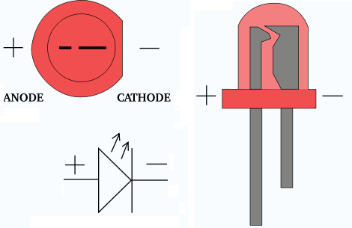
Fig 3.16: Electrical Symbol & Polarities of LED

LED lights have a variety of advantages over other light sources:
- High-levels of brightness and intensity
- High-efficiency
- Low-voltage and current requirements
- Low radiated heat
- High reliability (resistant to shock and vibration)
- No UV Rays
- Long source life
- Can be easily controlled and programmed

Applications of LED fall into three major categories:
- Visual signal application where the light goes more or less directly from the LED to the human eye, to convey a message or meaning.
- Illumination where LED light is reflected from object to give visual response of these objects.
- Generate light for measuring and interacting with processes that do not involve the

Arduino Uno Board
Arduino/Genuino Uno is a microcontroller board based on the ATmega328P (datasheet). It has 14 digital input/output pins (of which 6 can be used as PWM outputs), 6 analog inputs, a 16 MHz quartz crystal, a USB connection, a power jack, an ICSP header and a reset button. It contains everything needed to support the microcontroller; simply connect it to a computer with a USB cable or power it with a AC-to-DC adapter or battery to get started.. You can tinker with your UNO without worring too much about doing something wrong, worst case scenario you can replace the chip for a few dollars and start over again.
"Uno" means one in Italian and was chosen to mark the release of Arduino Software (IDE) 1.0. The Uno board and version 1.0 of Arduino Software (IDE) were the reference versions of Arduino, now evolved to newer releases. The Uno board is the first in a series of USB Arduino boards, and the reference model for the Arduino platform; for an extensive list of current, past or outdated boards see the Arduino index of boards.
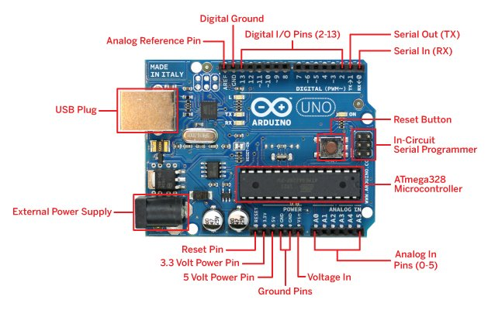
Arduino Board
ATMEGA 328P FEATURES
Microcontroller | ATmega328P
Operating Voltage | 5V
Input Voltage (recommended) | 7-12V
Input Voltage (limit) | 6-20V
Digital I/O Pins | 14 (of which 6 provide PWM output)
PWM Digital I/O Pins | 6
Analog Input Pins | 6
DC Current per I/O Pin | 20 mA
DC Current for 3.3V Pin | 50 mA
Flash Memory | 32 KB (ATmega328P)  of which 0.5 KB used by bootloader
SRAM | 2 KB (ATmega328P)
EEPROM | 1 KB (ATmega328P)
Clock Speed | 16 MHz
Length | 68.6 mm
Width | 53.4 mm
Weight | 25 g

DESCRIPTION
The high-performance Atmel picoPower 8-bit AVR RISC-based microcontroller combines 32KB ISP flash memory with read-while-write capabilities, 1024B EEPROM, 2KB SRAM, 23 general purpose I/O lines, 32 general purpose working registers, three flexible timer/counters with compare modes, internal and external interrupts, serial programmable USART, a byte-oriented 2-wire serial interface, SPI serial port, a 6-channel 10-bit A/D converter (8-channels in TQFP and QFN/MLF packages), programmable watchdog timer with internal oscillator, and five software selectable power saving modes. The device operates between 1.8-5.5 volts.
By executing powerful instructions in a single clock cycle, the device achieves throughputs approaching 1 MIPS per MHz, balancing power consumption and processing speed.
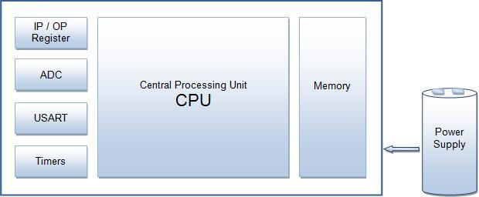
Block Diagram
PIN DIAGRAM
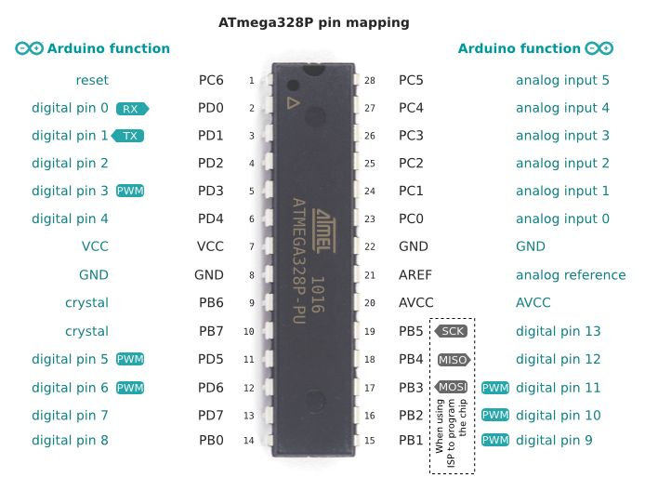
Pin Diagram
PIN DESCRIPTION

VCC

Digital supply voltage.

GND

Ground.

Port B (PB7:0) XTAL1/XTAL2/TOSC1/TOSC2

Port B is an 8-bit bi-directional I/O port with internal pull-up resistors (selected for each bit). The Port B output buffers have symmetrical drive characteristics with both high sink and source capability. As inputs, Port B pins that are externally pulled low will source current if the pull-up resistors are activated. The Port B pins are tristated when a reset condition becomes active, even if the clock is not running. Depending on the clock selection fuse settings, PB6 can be used as input to the inverting Oscillator amplifier and input to the internal clock operating circuit.

Depending on the clock selection fuse settings, PB7 can be used as output from the inverting Oscillator amplifier.

If the Internal Calibrated RC Oscillator is used as chip clock source, PB7...6 is used as TOSC2...1 input for the Asynchronous Timer/Counter2 if the AS2 bit in ASSR is set. The various special features of Port B are elaborated in ”Alternate Functions of Port B” on page 82 and ”System Clock and Clock Options”.

Port C (PC5:0)

Port C is a 7-bit bi-directional I/O port with internal pull-up resistors (selected for each bit). The PC5...0 output buffers have symmetrical drive characteristics with both high sink and source capability. As inputs, Port C pins that are externally pulled low will source current if the pull-up resistors are activated. The Port C pins are tristated when a reset condition becomes active, even if the clock is not running.

PC6/RESET

If the RSTDISBL Fuse is programmed, PC6 is used as an I/O pin. Note that the electrical characteristics of PC6 differ from those of the other pins of Port C.

If the RSTDISBL Fuse is unprogrammed, PC6 is used as a Reset input. A low level on this pin for longer than the minimum pulse length will generate a Reset, even if the clock is not running. The minimum pulse length is given in Table 29-11 on page 305. Shorter pulses are not guaranteed to generate a Reset.

Port D (PD7:0)

Port D is an 8-bit bi-directional I/O port with internal pull-up resistors (selected for each bit). The Port D output buffers have symmetrical drive characteristics with both high sink and source capability. As inputs, Port D pins that are externally pulled low will source current if the pull-up resistors are activated. The Port D pins are tristated when a reset condition becomes active, even if the clock is not running.

AVCC

AVCC is the supply voltage pin for the A/D Converter, PC3:0, and ADC7:6. It should be externally connected to VCC, even if the ADC is not used. If the ADC is used, it should be connected to VCC through a low-pass filter.

Note that PC6...4 use digital supply voltage, VCC.

AREF

AREF is the analog reference pin for the A/D Converter.

ADC7:6 (TQFP and QFN/MLF Package Only)

In the TQFP and QFN/MLF package, ADC7:6 serve as analog inputs to the A/D converter. These pins are powered from the analog supply and serve as 10-bit ADC channels.
Each of the 14 digital pins on the Uno can be used as an input or output, using pinMode(),digitalWrite(), and digitalRead() functions. They operate at 5 volts. Each pin can provide or receive 20 mA as recommended operating condition and has an internal pull-up resistor (disconnected by default) of 20-50k ohm. A maximum of 40mA is the value that must not be exceeded on any I/O pin to avoid permanent damage to the microcontroller.
In addition, some pins have specialized functions:
Serial: 0 (RX) and 1 (TX). Used to receive (RX) and transmit (TX) TTL serial data. These pins are connected to the corresponding pins of the ATmega8U2 USB-to-TTL Serial chip.
External Interrupts: 2 and 3. These pins can be configured to trigger an interrupt on a low value, a rising or falling edge, or a change in value. See the attachInterrupt() function for details.
PWM: 3, 5, 6, 9, 10, and 11. Provide 8-bit PWM output with the analogWrite() function.
SPI: 10 (SS), 11 (MOSI), 12 (MISO), 13 (SCK). These pins support SPI communication using the SPI library.
LED: 13. There is a built-in LED driven by digital pin 13. When the pin is HIGH value, the LED is on, when the pin is LOW, it's off.
TWI: A4 or SDA pin and A5 or SCL pin. Support TWI communication using the Wire library.
The Uno has 6 analog inputs, labeled A0 through A5, each of which provide 10 bits of resolution (i.e. 1024 different values). By default they measure from ground to 5 volts, though is it possible to change the upper end of their range using the AREF pin and the analogReference() function. There are a couple of other pins on the board:
AREF. Reference voltage for the analog inputs. Used with analogReference().
Reset. Bring this line LOW to reset the microcontroller. Typically used to add a reset button to shields which block the one on the board.
PROGRAMMING
The Arduino/Genuino Uno can be programmed with the (Arduino Software (IDE)). Select "Arduino/Genuino Uno from the Tools > Board menu (according to the microcontroller on your board). For details, see the reference and tutorials.
The ATmega328 on the Arduino/Genuino Uno comes preprogrammed with a bootloader that allows you to upload new code to it without the use of an external hardware programmer. It communicates using the original STK500 protocol (reference, C header files).
You can also bypass the bootloader and program the microcontroller through the ICSP (In-Circuit Serial Programming) header using Arduino ISP or similar; see these instructions for details.
The ATmega16U2 (or 8U2 in the rev1 and rev2 boards) firmware source code is available in the Arduino repository. The ATmega16U2/8U2 is loaded with a DFU bootloader, which can be activated by:
- On Rev1 boards: connecting the solder jumper on the back of the board (near the map of Italy) and then rese ing the 8U2.
- On Rev2 or later boards: there is a resistor that pulling the 8U2/16U2 HWB line to ground, making it easier to put into DFU mode.
You can then use Atmel's FLIP software (Windows) or the DFU programmer (Mac OS X and Linux) to load a new firmware. Or you can use the ISP header with an external programmer (overwriting the DFU bootloader). See this user-contributed tutorial for more information.
Differences with other boards

The Uno differs from all preceding boards in that it does not use the FTDI USB-to-serial driver chip. Instead, it features the Atmega16U2 (Atmega8U2 up to version R2) programmed as a USB-to-serial converter.
Communication
Arduino/Genuino Uno has a number of facilities for communicating with a computer, another Arduino/Genuino board, or other microcontrollers. The ATmega328 provides UART TTL (5V) serial communication, which is available on digital pins 0 (RX) and 1 (TX). An ATmega16U2 on the board channels this serial communication over USB and appears as a virtual com port to software on the computer. The 16U2 firmware uses the standard USB COM drivers, and no external driver is needed. However, on Windows, a .inf file is required. The Arduino Software (IDE) includes a serial monitor which allows simple textual data to be sent to and from the board. The RX and TX LEDs on the board will flash when data is being transmitted via the USB-to-serial chip and USB connection to the computer (but not for serial communication on pins 0 and 1).
A SoftwareSerial library allows serial communication on any of the Uno's digital pins.
The ATmega328 also supports I2C (TWI) and SPI communication. The Arduino Software (IDE) includes a Wire library to simplify use of the I2C bus; see the documentation for details. For SPI communication, use the SPI library.

Automatic (Software) Reset
Rather than requiring a physical press of the reset button before an upload, the Arduino/Genuino Uno board is designed in a way that allows it to be reset by software running on a connected computer. One of the hardware flow control lines (DTR) of the ATmega8U2/16U2 is connected to the reset line of the ATmega328 via a 100 nanofarad capacitor. When this line is asserted (taken low), the reset line drops long enough to reset the chip. The Arduino Software (IDE) uses this capability to allow you to upload code by simply pressing the upload button in the interface toolbar. This means that the bootloader can have a shorter timeout, as the lowering of DTR can be well-coordinated with the start of the upload.
This setup has other implications. When the Uno is connected to either a computer running Mac OS X or Linux, it resets each time a connection is made to it from software (via USB). For the following half-second or so, the bootloader is running on the Uno. While it is programmed to ignore malformed data (i.e. anything besides an upload of new code), it will intercept the first few bytes of data sent to the board after a connection is opened. If a sketch running on the board receives one-time configuration or other data when it first starts, make sure that the software with which it communicates waits a second after opening the connection and before sending this data.
The Uno board contains a trace that can be cut to disable the auto-reset. The pads on either side of the trace can be soldered together to re-enable it. It's labeled "RESET-EN". You may also be able to disable the auto-reset by connecting a 110 ohm resistor from 5V to the reset line.
GLOBAL SYSTEM FOR MOBILE
Global System for Mobile Communications (GSM) modems are specialized types of modems that operate over subscription based wireless networks, similar to a mobile phone. A GSM modem accepts a Subscriber Identity Module (SIM) card, and basically acts like a mobile phone for a computer. Such a modem can even be a dedicated mobile phone that the computer uses for GSM network capabilities.
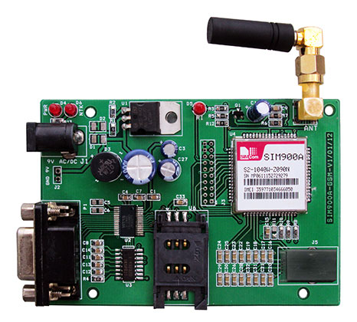
Fig: GSM Modem

3.10.1 FEATURES
- Compatibility with integrated services digital network (ISDN)
- High-quality speech
- Short message service (SMS)
- Status of Modem Indicated by LED
- Simple to Use & Low Cost
- On board switching type power supply regulator
- RS232 output
3.10.2 INTERFACING GSM MODEM
This GSM Modem can accept any GSM network operator SIM card and act just like a mobile phone with its own unique phone number. Advantage of using this modem will be that you can use its RS232 port to communicate and develop embedded applications. Applications like SMS Control, data transfer, remote control and logging can be developed easily.
Traditional modems are attached to computers to allow dial-up connections to other computer systems. A GSM modem operates in a similar fashion, except that it sends and receives data through radio waves rather than a telephone line. This type of modem may be an external device connected via a Universal Serial Bus (USB) cable or a serial cable. More commonly, however, it is a small device that plugs directly into the USB port or card slot on a computer or laptop. It is widely used mobile communication system in the world. GSM is an open and digital cellular technology used for transmitting mobile voice and data services operates at the 850MHz, 900MHz, 1800MHz and 1900MHz frequency bands.
3.10.3 AT COMMANDS
A GSM modem is a wireless modem that works with a GSM wireless network. A wireless modem behaves like a dial-up modem. The main difference between them is that a dial-up modem sends and receives data through a fixed telephone line while a wireless modem sends and receives data through radio waves.
AT commands are use to control modems. Both GSM modems and dial-up modems support a common set of standard AT commands. You can use a GSM modem just like a dial-up modem.
In addition to the standard AT commands, GSM modems support an extended set of AT commands. These extended AT commands are defined in the GSM standards. With the extended AT commands, you can do things like:
- Reading, writing and deleting SMS messages.
- Sending SMS messages.
- Monitoring the signal strength.
- Monitoring the charging status and charge level of the battery.
- Reading, writing and searching phone book entries.
- The number of SMS messages that can be processed by a GSM modem per minute is very low -only about six to ten SMS messages per minute.
3.10.4 Applications
- SMS based Remote Control & Alerts
- Security Applications
- Sensor Monitoring
- GPRS Mode Remote Data Logging

GPS (GLOBAL POSITIONING SYSTEM)
The Global Positioning System (GPS) is a U.S. space-based radio navigation system that provides reliable positioning, navigation, and timing services to civilian users on a continuous worldwide basis -- freely available to all. For anyone with a GPS receiver, the system will provide location and time. GPS provides accurate location and time information for an unlimited number of people in all weather, day and night, anywhere in the world.
The GPS is made up of three parts:
1. Satellites orbiting the Earth
2. Control and monitoring stations on Earth
3. The GPS receivers owned by users.
GPS satellites broadcast signals from space that are picked up and identified by GPS receivers. Each GPS receiver then provides three-dimensional location (latitude, longitude, and altitude) plus the time.
- SPACE SEGMENT
- 24+ satellites
- 20,200 km altitude
- 55 degrees inclination
- 12 hour orbital period
- 5 ground control stations
- Each satellite passes over a ground monitoring station every 12 hours

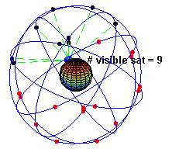

The GPS satellite system

The space segment is composed of the orbiting GPS satellites or Space Vehicles (SV) in GPS parlance. The GPS design originally called for 24 SVs, this was modified to six planes with four satellites each. The orbital planes are centered on the Earth, not rotating with respect to the distant stars. The six planes have approximately 55° inclination (tilt relative to Earth's equator) and are separated by 60° right ascension of the ascending node (angle along the equator from a reference point to the orbit's intersection). The orbits are arranged so that at least six satellites are always within line of sight from almost everywhere on Earth's surface.
The full constellation of 24 satellites that make up the GPS space segment are orbiting the earth about 20,200 km above us. They are constantly moving, making two complete orbits in less than 24 hours. These satellites are travelling at speeds of roughly 7,000 miles an hour.
GPS satellites are powered by solar energy. They have backup batteries onboard to keep them running in the event of a solar eclipse, when there's no solar power. Small rocket boosters on each satellite keep them flying in the correct path.
Here are some other interesting facts about the GPS satellites (also called NAVSTAR, the official U.S. Department of Defense name for GPS):
- The first GPS satellite was launched in 1978.
- A full constellation of 24 satellites was achieved in 1994.
- Each satellite is built to last about 10 years. Replacements are constantly being built and launched into orbit.
- A GPS satellite weighs approximately 2,000 pounds and is about 17 feet across with the solar panels extended.
- Transmitter power is only 50 watts or less.
- The orbits are arranged so that at any time, anywhere on Earth, there are at least four satellites "visible" in the sky.
- All satellites broadcast at the same two frequencies, 1.57542 GHz (L1 signal) and 1.2276 GHz (L2 signal).
- The satellite network uses a CDMA spread-spectrum technique where the low-bitrate message data is encoded with a high-rate pseudo-random (PRN) sequence that is different for each satellite.
The receiver must be aware of the PRN codes for each satellite to reconstruct the actual message data. The C/A code, for civilian use, transmits data at 1.023 million chips per second, whereas the P code, for U.S. military use, transmits at 10.23 million chips per second. The L1 carrier is modulated by both the C/A and P codes, while the L2 carrier is only modulated by the P code. The P code can be encrypted as a so-called P(Y) code which is only available to military equipment with a proper decryption key. Both the C/A and P(Y) codes impart the precise time-of-day to the user

- Control and monitoring stations on Earth
Ground Stations (also known as the "Control Segment")
These stations monitor the GPS satellites, checking both their operational health and their exact position in space. The master ground station transmits corrections for the satellite's ephemeris constants and clock offsets back to the satellites themselves. The satellites can then incorporate these updates in the signals they send to GPS receivers.
There are five monitor stations: Hawaii, Ascension Island, Diego Garcia, Kwajalein, and Colorado Springs.
Each GPS satellite regularly with a navigational update using dedicated or shared ground antennas (GPS dedicated ground antennas are located at Kwajalein, Ascension Island, Diego Garcia, and Cape Canaveral). These updates synchronize the atomic clocks on board the satellites to within a few nanoseconds of each other, and adjust the ephemeris of each satellite's internal orbital model. The updates are created by a Kalman filter, which uses inputs from the ground monitoring stations, space weather information, and various other inputs. Satellite maneuvers are not precise by GPS standards. So to change the orbit of a satellite, the satellite must be marked unhealthy, so receivers will not use it in their calculation. Then the maneuver can be carried out, and the resulting orbit tracked from the ground. Then the new ephemeris is uploaded and the satellite marked healthy again.

ALCOHOLIC SENSOR
Alcohol Sensor for use in Breathalyzer’s or in an alarm unit, to detect the presence of alcohol vapors. This sensor unit offers very high sensitivity, combined with a fast response time. The unit will work with a simple drive circuit and offers excellent stability with long life. When all the acetic acid is cleared out of the FUEL CELL, the instrument is ready to analyze another sample.

Character
* High sensitivity
* Fast response and resume
* Long life and low cost
* Mini Size

Application
- It has good sensitivity and fast response to alcohol, suitable for portable alcohol detector.

Specifications

- Supply Voltage =12V DC
- Current IH 120±20mA
- Power PH ≤ 140 mW

It reflects change from voltage change on fixed or adjustable relation of load resistance.

LCD MODULE

To display interactive messages we are using LCD Module. We examine an intelligent LCD display of two lines,16 characters per line that is interfaced to the controllers. The protocol (handshaking) for the display is as shown. Whereas D0 to D7th bit is the Data lines, RS, RW and EN pins are the control pins and remaining pins are +5V, -5V and GND to provide supply. Where RS is the Register Select, RW is the Read Write and EN is the Enable pin.
The display contains two internal byte-wide registers, one for commands (RS=0) and the second for characters to be displayed (RS=1). It also contains a user-programmed RAM area (the character RAM) that can be programmed to generate any desired character that can be formed using a dot matrix. To distinguish between these two data areas, the hex command byte 80 will be used to signify that the display RAM address 00h will be chosen.Port1 is used to furnish the command or data type, and ports 3.2 to3.4 furnish register select and read/write levels.
The display takes varying amounts of time to accomplish the functions as listed. LCD bit 7 is monitored for logic high (busy) to ensure the display is overwritten.
Liquid Crystal Display also called as LCD is very helpful in providing user interface as well as for debugging purpose. The most common type of LCD controller is HITACHI 44780 which provides a simple interface between the controller & an LCD. These LCD's are very simple to interface with the controller as well as are cost effective.
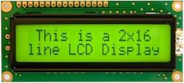
2x16 Line Alphanumeric LCD Display
The most commonly used ALPHANUMERIC displays are 1x16 (Single Line & 16 characters), 2x16 (Double Line & 16 character per line) & 4x20 (four lines & Twenty characters per line).
The LCD requires 3 control lines (RS, R/W & EN) & 8 (or 4) data lines. The number on data lines depends on the mode of operation. If operated in 8-bit mode then 8 data lines + 3 control lines i.e. total 11 lines are required. And if operated in 4-bit mode then 4 data lines + 3 control lines i.e. 7 lines are required. How do we decide which mode to use? It’s simple if you have sufficient data lines you can go for 8 bit mode & if there is a time constrain i.e. display should be faster then we have to use 8-bit mode because basically 4-bit mode takes twice as more time as compared to 8-bit mode.
Pin | Symbol | Function
1 | Vss | Ground
2 | Vdd | Supply Voltage
3 | Vo | Contrast Setting
4 | RS | Register Select
5 | R/W | Read/Write Select
6 | En | Chip Enable Signal
7-14 | DB0-DB7 | Data Lines
15 | A/Vee | Gnd for the backlight
16 | K | Vcc for backlight
When RS is low (0), the data is to be treated as a command. When RS is high (1), the data being sent is considered as text data which should be displayed on the screen.
When R/W is low (0), the information on the data bus is being written to the LCD. When RW is high (1), the program is effectively reading from the LCD. Most of the times there is no need to read from the LCD so this line can directly be connected to Gnd thus saving one controller line.
The ENABLE pin is used to latch the data present on the data pins. A HIGH - LOW signal is required to latch the data. The LCD interprets and executes our command at the instant the EN line is brought low. If you never bring EN low, your instruction will never be executed.
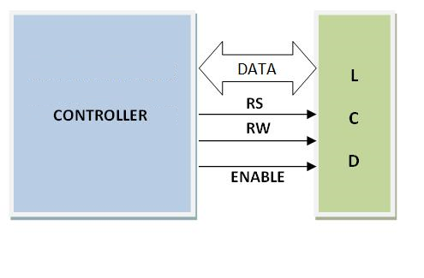

COMMANDS USED IN LCD

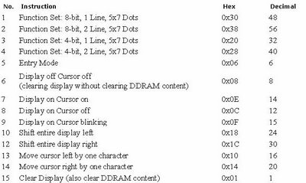

Basic 16x 2 Characters LCD - Black on Green 5V:
Description:
This is a basic 16 character by 2 line display. Black text on Green background. Utilizes the extremely common HD44780 parallel interface chipset. Interface code is freely available. We will need ~11 general I/O pins to interface to this LCD screen. Includes LED backlight.
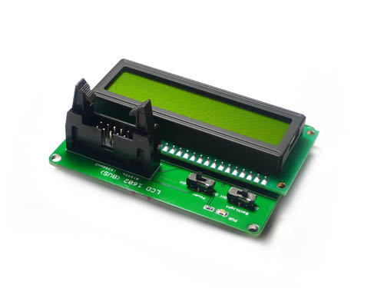

Pin Description:
The most commonly used LCDs found in the market today are 1 Line, 2 Line or 4 Line LCDs which have only 1 controller and support at most of 80 characters, whereas LCDs supporting more than 80 characters make use of 2 HD44780 controllers.
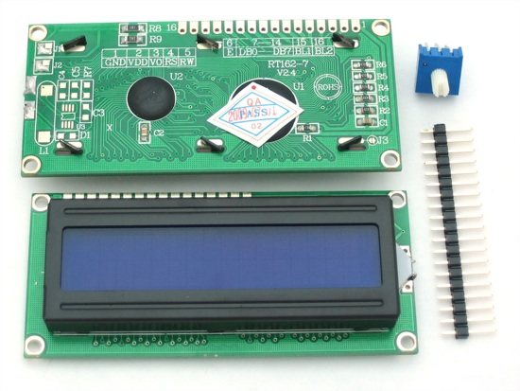

Most LCDs with 1 controller has 14 Pins and LCDs with 2 controller has 16 Pins (two pins are extra in both for back-light LED connections). Pin description is shown in the table below.
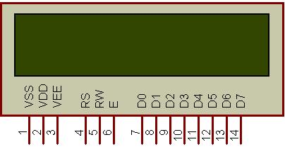
Figure 1: Character LCD type HD44780 Pin diagram

Pin description:

Pin No. | Name | Description
Pin no. 1 | VSS | Power supply (GND)
Pin no. 2 | VCC | Power supply (+5V)
Pin no. 3 | VEE | Contrast adjust
Pin no. 4 | RS | 0 = Instruction input  1 = Data input
Pin no. 5 | R/W | 0 = Write to LCD module  1 = Read from LCD module
Pin no. 6 | EN | Enable signal
Pin no. 7 | D0 | Data bus line 0 (LSB)
Pin no. 8 | D1 | Data bus line 1
Pin no. 9 | D2 | Data bus line 2
Pin no. 10 | D3 | Data bus line 3
Pin no. 11 | D4 | Data bus line 4
Pin no. 12 | D5 | Data bus line 5
Pin no. 13 | D6 | Data bus line 6
Pin no. 14 | D7 | Data bus line 7 (MSB)
Table 1: Character LCD pins with 1 Controller

Pin No. | Name | Description
Pin no. 1 | D7 | Data bus line 7 (MSB)
Pin no. 2 | D6 | Data bus line 6
Pin no. 3 | D5 | Data bus line 5
Pin no. 4 | D4 | Data bus line 4
Pin no. 5 | D3 | Data bus line 3
Pin no. 6 | D2 | Data bus line 2
Pin no. 7 | D1 | Data bus line 1
Pin no. 8 | D0 | Data bus line 0 (LSB)
Pin no. 9 | EN1 | Enable signal for row 0 and 1 (1stcontroller)
Pin no. 10 | R/W | 0 = Write to LCD module  1 = Read from LCD module
Pin no. 11 | RS | 0 = Instruction input  1 = Data input
Pin no. 12 | VEE | Contrast adjust
Pin no. 13 | VSS | Power supply (GND)
Pin no. 14 | VCC | Power supply (+5V)
Pin no. 15 | EN2 | Enable signal for row 2 and 3 (2ndcontroller)
Pin no. 16 | NC | Not Connected
Table 2: Character LCD pins with 2 Controller

LCD Background:
Frequently, an 8051 program must interact with the outside world using input and output devices that communicate directly with a human being. One of the most common devices attached to an 8051 is an LCD display. Some of the most common LCDs connected to the 8051 are 16x2 and 20x2 displays. This means 16 characters per line by 2 lines and 20 characters per line by 2 lines, respectively.

Fortunately, a very popular standard exists which allows us to communicate with the vast majority of LCDs regardless of their manufacturer. The standard is referred to as HD44780U, which refers to the controller chip which receives data from an external source (in this case, the 8051) and communicates directly with the LCD.

44780 Background:
The 44780 standard requires 3 control lines as well as either 4 or 8 I/O lines for the data bus. The user may select whether the LCD is to operate with a 4-bit data bus or an 8-bit data bus. If a 4-bit data bus is used the LCD will require a total of 7 data lines (3 control lines plus the 4 lines for the data bus). If an 8-bit data bus is used the LCD will require a total of 11 data lines (3 control lines plus the 8 lines for the data bus).

The three control lines are referred to as EN, RS, and RW.
The EN line is called "Enable." This control line is used to tell the LCD that we are sending it data. To send data to the LCD, our program should make sure this line is low (0) and then set the other two control lines and/or put data on the data bus. When the other lines are completely ready, bring EN high (1) and wait for the minimum amount of time required by the LCD datasheet (this varies from LCD to LCD), and end by bringing it low (0) again.

The RS line is the "Register Select" line. When RS is low (0), the data is to be treated as a command or special instruction (such as clear screen, position cursor, etc.). When RS is high (1), the data being sent is text data which should be displayed on the screen. For example, to display the letter "T" on the screen we would set RS high.

The RW line is the "Read/Write" control line. When RW is low (0), the information on the data bus is being written to the LCD. When RW is high (1), the program is effectively querying (or reading) the LCD. Only one instruction ("Get LCD status") is a read command. All others are write commands--so RW will almost always be low.

Finally, the data bus consists of 4 or 8 lines (depending on the mode of operation selected by the user). In the case of an 8-bit data bus, the lines are referred to as DB0, DB1, DB2, DB3, DB4, DB5, DB6, and DB7.
Interfacing Example - 16 Characters x 2 Lines LCD:
Description:
This is the first interfacing example for the Parallel Port. We will start with something simple. This example doesn't use the Bi-directional feature found on newer ports, thus it should work with most, if no all Parallel Ports.

It however doesn't show the use of the Status Port as an input. A 16 Character x 2 Line LCD Module to the Parallel Port. These LCD Modules are very common these days, and are quite simple to work with, as all the logic required running them is on board.

Schematic:

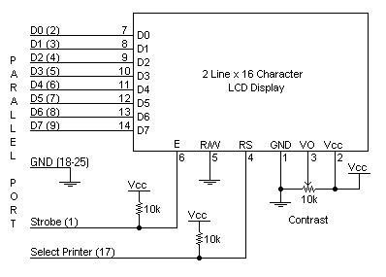

Circuit Description:
Above is the quite simple schematic. The LCD panel's Enable and Register Select is connected to the Control Port. The Control Port is an open collector / open drain output. While most Parallel Ports have internal pull-up resistors, there is a few which don't. Therefore by incorporating the two 10K external pull up resistors, the circuit is more portable for a wider range of computers, some of which may have no internal pull up resistors.

We make no effort to place the Data bus into reverse direction. Therefore we hard wire the R/W line of the LCD panel, into write mode. This will cause no bus conflicts on the data lines. As a result we cannot read back the LCD's internal Busy Flag which tells us if the LCD has accepted and finished processing the last instruction. This problem is overcome by inserting known delays into our program.

The 10k Potentiometer controls the contrast of the LCD panel. Nothing fancy here. As with all the examples, I've left the power supply out. We can use a bench power supply set to 5v or use an onboard +5 regulator. Remember a few de-coupling capacitors, especially if we have trouble with the circuit working properly.

An example hardware configuration:
As we've mentioned, the LCD requires either 8 or 11 I/O lines to communicate with. For the sake of this tutorial, we are going to use an 8-bit data bus--so we'll be using 11 of the 8051's I/O pins to interface with the LCD.

Let's draw a sample pseudo-schematic of how the LCD will be connected to the 8051.
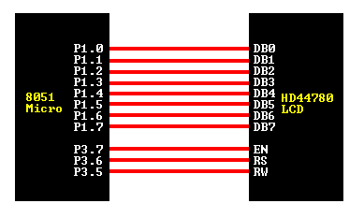
As we can see, we've established a 1-to-1 relation between a pin on the 8051 and a line on the 44780 LCD. Thus as we write our assembly program to access the LCD, we are going to equate constants to the 8051 ports so that we can refer to the lines by their 44780 name as opposed to P0.1, P0.2, etc. Let's go ahead and write our initial equates:

DB0 EQU P1.0
DB1 EQU P1.1
DB2 EQU P1.2
DB3 EQU P1.3
DB4 EQU P1.4
DB5 EQU P1.5
DB6 EQU P1.6
DB7 EQU P1.7
EN EQU P3.7
RS EQU P3.6
RW EQU P3.5
DATA EQU P1

Having established the above equates, we may now refer to our I/O lines by their 44780 name. For example, to set the RW line high (1), we can execute the following instruction:
SETB RW
Handling the EN control line:
As we mentioned above, the EN line is used to tell the LCD that we are ready for it to execute an instruction that we've prepared on the data bus and on the other control lines. Note that the EN line must be raised/ lowered before/after each instruction sent to the LCD regardless of whether that instruction is read or write text or instruction. In short, we must always manipulate EN when communicating with the LCD. EN is the LCD's way of knowing that we are talking to it. If we don't raise/lower EN, the LCD doesn't know we're talking to it on the other lines.

Thus, before we interact in any way with the LCD we will always bring the EN line low with the following instruction:

CLR EN
And once we've finished setting up our instruction with the other control lines and data bus lines, we'll always bring this line high:
SETB EN
The line must be left high for the amount of time required by the LCD as specified in its datasheet. This is normally on the order of about 250 nanoseconds, but checks the datasheet. In the case of a typical 8051 running at 12 MHz, an instruction requires 1.08 microseconds to execute so the EN line can be brought low the very next instruction. However, faster microcontrollers (such as the DS89C420 which executes an instruction in 90 nanoseconds given an 11.0592 MHz crystal) will require a number of NOPs to create a delay while EN is held high. The number of NOPs that must be inserted depends on the microcontroller we are using and the crystal we have selected.

The instruction is executed by the LCD at the moment the EN line is brought low with a final CLR EN instruction.

Checking the busy status of the LCD:
As previously mentioned, it takes a certain amount of time for each instruction to be executed by the LCD. The delay varies depending on the frequency of the crystal attached to the oscillator input of the 44780 as well as the instruction which is being executed.

While it is possible to write code that waits for a specific amount of time to allow the LCD to execute instructions, this method of "waiting" is not very flexible. If the crystal frequency is changed, the software will need to be modified. Additionally, if the LCD itself is changed for another LCD which, although 44780 compatible, requires more time to perform its operations, the program will not work until it is properly modified.
A more robust method of programming is to use the "Get LCD Status" command to determine whether the LCD is still busy executing the last instruction received.

The "Get LCD Status" command will return to us two tidbits of information; the information that is useful to us right now is found in DB7. In summary, when we issue the "Get LCD Status" command the LCD will immediately raise DB7 if it's still busy executing a command or lower DB7 to indicate that the LCD is no longer occupied. Thus our program can query the LCD until DB7 goes low, indicating the LCD is no longer busy. At that point we are free to continue and send the next command.

Since we will use this code every time we send an instruction to the LCD, it is useful to make it a subroutine. Let's write the code:

WAIT_LCD:
CLR EN ;Start LCD command
CLR RS ;It's a command
SETB RW ;It's a read command
MOV DATA, #0FFh ;Set all pins to FF initially
SETB EN ;Clock out command to LCD
MOV A,DATA ;Read the return value
JB ACC.7,WAIT_LCD;If bit 7 high, LCD still busy
CLR EN ;Finish the command
CLR RW ;Turn off RW for future commands
RET

Thus, our standard practice will be to send an instruction to the LCD and then call our WAIT_LCD routine to wait until the instruction is completely executed by the LCD. This will assure that our program gives the LCD the time it needs to execute instructions and also makes our program compatible with any LCD, regardless of how fast or slow it is.
The last byte we need to send is used to configure additional operational parameters of the LCD. We must send the value 06h.
CLR RS
MOV DATA, #06h
SETB EN
CLR EN
LCALL WAIT_LCD

So, in all, our initialization code is as follows:
INIT_LCD:
CLR RS
MOV DATA, #38h
SETB EN
CLR EN
LCALL WAIT_LCD
CLR RS
MOV DATA, #0Eh
SETB EN
CLR EN
LCALL WAIT_LCD
CLR RS
MOV DATA, #06h
SETB EN
CLR EN
LCALL WAIT_LCD
RET

Having executed this code the LCD will be fully initialized and ready for us to send display data to it.

CLEARING THE DISPLAY:
When the LCD is first initialized, the screen should automatically be cleared by the 44780 controller. However, it's always a good idea to do things our self so that we can be completely sure that the display is the way we want it. Thus, it's not a bad idea to clear the screen as the very first operation after the LCD has been initialized.

An LCD command exists to accomplish this function. Not surprisingly, it is the command 01h. Since clearing the screen is a function we very likely will wish to call more than once, it's a good idea to make it a subroutine:

CLEAR_LCD:
CLR RS
MOV DATA, #01h
SETB EN
CLR EN
LCALL WAIT_LCD
RET

How that we've written a "Clear Screen" routine, we may clear the LCD at any time by simply executing an LCALL CLEAR_LCD.

Applications:
- Medical equipment
- Electronic test equipment
- Industrial machinery Interface
- Serial terminal
- Advertising system
- EPOS
- Restaurant ordering systems
- Gaming box
- Security systems
- R&D Test units
- Climatizing units
- PLC Interface
- Simulators
- Environmental monitoring
- Lab development
- Student projects
- Home automation
- PC external display
- HMI operator interface.
- APR 9600 VOICE IC:
- The APR9600 device offers true single-chip voice recording, non-volatile storage, and playback capability for 40 to 60 seconds. The IC is 28 pin device used to record & playback of maximum of 8 messages. The device supports both random and sequential access of multiple messages. Sample rates are user-selectable, allowing designers to customize their design for unique quality and storage time needs. the device is ideal for use in portable voice recorders, toys, and many other consumer and industrial applications.

- The replayed sound exhibits high quality with a low noise level. Sampling rate for a 60 second recording period is 4.2 kHz that gives a sound record/replay bandwidth of 20Hz to 2.1 kHz. However, by changing an oscillation resistor, a sampling rate as high as 8.0 kHz can be achieved. This shortens the total length of sound recording to 32 seconds.

- Total sound recording time can be varied from 32 seconds to 60 seconds by changing the value of a single resistor. The IC can operate in one of two modes: serial mode and parallel mode. In serial access mode, sound can be recorded in 256 sections. In parallel access mode, sound can be recorded in 2, 4 or 8 sections. The IC can be controlled simply using push button keys. It is also possible to control the IC using external digital circuitry such as micro-controllers and computers.

- This APR9600 voice IC has 28 pin DIP package works in supply voltage between 4.5V & 6.5V. During recording and replaying, current consumption is 25 mA. In idle mode, the current drops to 1 mA. The APR9600 experimental board is an assembled PCB board consisting of an APR9600 IC, an electrets microphone, support components and necessary switches to allow users to explore all functions of the APR9600 chip. The oscillation resistor is chosen so that the total recording period is 60 seconds with a sampling rate of 4.2 kHz. The board measures 80mm by 55mm.

- Fig: APR9600 Experimental board

- APR9600

- Pin-out of the APR9600 is given in Figure 1. A typical connection of the chip is given in Figure 2 (This is the circuit diagram of the module). Pin functions of the IC are given in Table 1. During sound recording, sound is picked up by the microphone. A microphone pre-amplifier amplifies the voltage signal from the microphone. An AGC circuit is included in the pre-amplifier, the extent of which is controlled by an external capacitor and resistor. If the voltage level of a sound signal is around 100 mV peak to- peak, the signal can be fed directly into the IC through ANA IN pin (pin 20). The sound signal passes through a filter and a sampling and hold circuit. The analogue voltage is then written into non-volatile flash analogue RAMs. It has a 28 pin DIP package. Supply voltage is between 4.5V to 6.5V. During recording and replaying, current consumption is 25 mA. In idle mode, the current drops to 1 mA.

- PIN DIAGRAM
- Fig: Pin-out of APR9600

- Fig: Typical connections of the APR9600
- APR9600 MODULE

- The circuit diagram of the module is shown in Figure 2. The module consists of an APR9600 chip, an electrets microphone, support components, a mode selection switch (-RE, MSEL1, MSEL2 and – M8) and 9 keys (-M1 to –M8 and CE). The oscillation resistor is chosen so that the total recording period is 60 seconds with a sampling rate of 4.2 kHz. Users can change the value of the ROSC to obtain other sampling frequencies. It should be noted that if the sampling rate is increased, the length of recording time is decreased. Table 3 gives the details. An 8-16 Ohm speaker is to be used with the module. Users can select different modes using the mode selection switch. The module is measured 80mm´55mm. Connection points (0-8, C and B) can connect to other switches or external digital circuits. In this cased, on-board keys M1 to M8 and CE are by-passed.

- TIPS FOR BETTER SOUND REPLAY QUALITY:

- 1. Use a good quality 8 Ohm speaker with a cavity such as speakers for computer sound systems. Do not use a bare speaker which gives you degraded sound.
- 2. For better sound replay quality, speak with a distance to the on-board microphone and speak clearly. Also keep the background noise as low as possible.
- 3. For even better sound replay quality, use microphone input or Audio Line In input. If Audio Line In is used, the amplitude of input signal should be < 100 mV p-p.

RELAY

INTRODUCTION
A relay is an electromechanical switch, which perform ON and OFF operations without any human interaction. General representation of double contact relay is shown in fig. Relays are used where it is necessary to control a circuit by a low-power signal (with complete electrical isolation between control and controlled circuits), or where several circuits must be controlled by one signal.
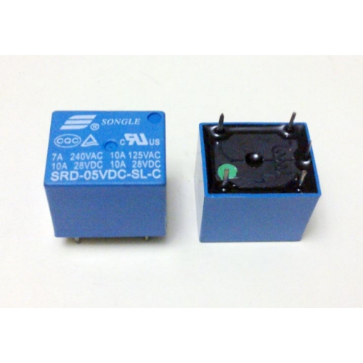
Fig. Relay
History

The first relay was invented by Joseph Henry in 1835. The name relay derives from the French noun relays’ that indicates the horse exchange place of the postman. Generally a relay is an electrical hardware device having an input and output gate. The output gate consists in one or more electrical contacts that switch when the input gate is electrically excited. It can implement a decoupled, a router or breaker for the electrical power, a negation, and, on the base of the wiring, complicated logical functions containing and, or, and flip-flop. In the past relays had a wide use, for instance the telephone switching or the railway routing and crossing systems. In spite of electronic progresses (as programmable devices), relays are still used in applications where ruggedness, simplicity, long life and high reliability are important factors (for instance in safety applications)

Working
Generally, the relay consists a inductor coil, a spring (not shown in the figure), Swing terminal, and two high power contacts named as normally closed (NC) and normally opened (NO). Relay uses an Electromagnet to move swing terminal between two contacts (NO and NC). When there is no power applied to the inductor coil (Relay is OFF), the spring holds the swing terminal is attached to NC contact.
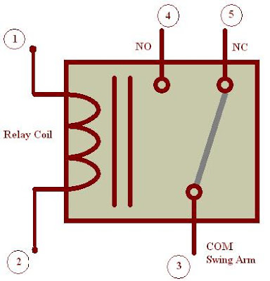
Fig. Representation of Relay
Whenever required power is applied to the inductor coil, the current flowing through the coil generates a magnetic field which is helpful to move the swing terminal and attached it to the normally open (NO) contact. Again when power is OFF, the spring restores the swing terminal position to NC.

Advantage of relay:
A relay takes small power to turn ON, but it can control high power devices to switch ON and OFF. Consider an example; a relay is used t control the ceiling FAN at our home. The ceiling FAN may runs at 230V AC and draws a current maximum of 4A. Therefore the power required is 4X230 = 920 watts. Off course we can control AC, lights, etc., depend up on the relay ratings. Relays can be used to control DC motors in ROBOTICs.

DC MOTOR
A DC Motor in simple words is a device that converts direct current (electrical energy) into mechanical energy. It’s of vital importance for the industry today.
Gear DC Motor
Geared DC motors can be defined as an extension of DC motor. A geared DC Motor has a gear assembly attached to the motor. The speed of motor is counted in terms of rotations of the shaft per minute and is termed as RPM .The gear assembly helps in increasing the torque and reducing the speed. Using the correct combination of gears in a gear motor, its speed can be reduced to any desirable figure. This concept where gears reduce the speed of the vehicle but increase its torque is known as gear reduction. This Insight will explore all the minor and major details that make the gear head and hence the working of geared DC motor.
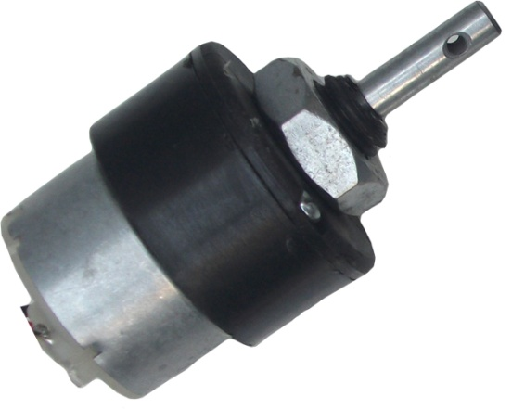
Fig. Motor
WORKING
The DC motor works over a fair range of voltage. The higher the input voltage more is the RPM (rotations per minute) of the motor. For example, if the motor works in the range of 6-12V, it will have the least RPM at 6V and maximum at 12 V. The speed of a DC motor can be controlled by changing the voltage applied to the armature or by changing the field current. The introduction of variable resistance in the armature circuit or field circuit allowed speed control. Modern DC motors are often controlled by power electronics systems called DC drives.
Usage
The DC motor or Direct Current Motor to give it its full title, is the most commonly used actuator for producing continuous movement and whose speed of rotation can easily be controlled, making them ideal for use in applications were speed control, servo type control, and/or positioning is required. Our gear motors are used for various applications in the areas of medicine and healthcare, automobile systems, drive systems, or as a variety of positioning or industrial / consumer actuators.

CHAPTER 4
SOFTWARE SPECIFICATION
The Arduino Integrated Development Environment - or Arduino Software (IDE) - contains a text editor for writing code, a message area, a text console, a toolbar with buttons for common functions and a series of menus. It connects to the Arduino and Genuino hardware to upload programs and communicate with them.

WRITING SKETCHES
Programs written using Arduino Software (IDE) are called sketches. These sketches are written in the text editor and are saved with the file extension .ino. The editor has features for cutting/pasting and for searching/replacing text. The message area gives feedback while saving and exporting and also displays errors. The console displays text output by the Arduino Software (IDE), including complete error messages and other information. The bottom righthand corner of the window displays the configured board and serial port. The toolbar buttons allow you to verify and upload programs, create, open, and save sketches, and open the serial monitor.
NB: Versions of the Arduino Software (IDE) prior to 1.0 saved sketches with the extension .pde. It is possible to open these files with version 1.0, you will be prompted to save the sketch with the .ino extension on save.
Verify
Checks your code for errors compiling it.
Upload
Compiles your code and uploads it to the configured board. See uploading below for details.
Note: If you are using an external programmer with your board, you can hold down the "shift" key on your computer when using this icon. The text will change to "Upload using Programmer"
New Creates a new sketch.
Open Presents a menu of all the sketches in your sketchbook. Clicking one will open it within the current window overwriting its content.
Note: due to a bug in Java, this menu doesn't scroll; if you need to open a sketch late in the list, use the File | Sketchbookmenu instead.
Save Saves your sketch.
Serial Monitor Opens the serial monitor.
Additional commands are found within the five menus: File, Edit, Sketch, Tools, Help. The menus are context sensitive, which means only those items relevant to the work currently being carried out are available.

File
- New Creates a new instance of the editor, with the bare minimum structure of a sketch already in place.
- Open Allows to load a sketch file browsing through the computer drives and folders.
- Open Recent Provides a short list of the most recent sketches, ready to be opened.
- Sketchbook Shows the current sketches within the sketchbook folder structure; clicking on any name opens the corresponding sketch in a new editor instance.
- Examples Any example provided by the Arduino Software (IDE) or library shows up in this menu item. All the examples are structured in a tree that allows easy access by topic or library.
- Close Closes the instance of the Arduino Software from which it is clicked.
- Save Saves the sketch with the current name. If the file hasn't been named before, a name will be provided in a "Save as.." window.
- Saveas... Allows to save the current sketch with a different name.
- PageSetup It shows the Page Setup window for printing.
- Print
Sends the current sketch to the printer according to the settings defined in Page Setup.
- Preferences
Opens the Preferences window where some settings of the IDE may be customized, as the language of the IDE interface.
- Quit
Closes all IDE windows. The same sketches open when Quit was chosen will be automatically reopened the next time you start the IDE.

EDIT
- Undo/Redo
Goes back of one or more steps you did while editing; when you go back, you may go forward with Redo.
- Cut
Removes the selected text from the editor and places it into the clipboard.
- Copy
Duplicates the selected text in the editor and places it into the clipboard.
- Copy for Forum Copies the code of your sketch to the clipboard in a form suitable for posting to the forum, complete with syntax coloring.
- Copy as HTML Copies the code of your sketch to the clipboard as HTML, suitable for embedding in web pages.
- Paste
Puts the contents of the clipboard at the cursor position, in the editor.
- Select All Selects and highlights the whole content of the editor.
- Comment/Uncomment
Puts or removes the // comment marker at the beginning of each selected line.
- Increase/Decrease Indent :Adds or subtracts a space at the beginning of each selected line, moving the text one space on the right or eliminating a space at the beginning.
- Find
Opens the Find and Replace window where you can specify text to search inside the current sketch according to several options.
- Find Next: Highlights the next occurrence - if any - of the string specified as the search item in the Find window, relative to the cursor position.
- Find Previous : Highlights the previous occurrence - if any - of the string specified as the search item in the Find window relative to the cursor position.

SKETCH
- Verify/Compile
Checks your sketch for errors compiling it; it will report memory usage for code and variables in the console area.
- Upload
Compiles and loads the binary file onto the configured board through the configured Port.
- Upload Using Programmer
This will overwrite the bootloader on the board; you will need to use Tools > Burn Bootloader to restore it and be able to Upload to USB serial port again. However, it allows you to use the full capacity of the Flash memory for your sketch. Please note that this command will NOT burn the fuses. To do so a Tools -> Burn Bootloader command must be executed.
- Export Compiled Binary
Saves a .hex file that may be kept as archive or sent to the board using other tools.
- Show Sketch Folder
Opens the current sketch folder.
- Include Library
Adds a library to your sketch by inserting #include statements at the start of your code. For more details, seelibraries below. Additionally, from this menu item you can access the Library Manager and import new libraries from .zip files.
- Add File...
Adds a source file to the sketch (it will be copied from its current location). The new file appears in a new tab in the sketch window. Files can be removed from the sketch using the tab menu accessible clicking on the small triangle icon below the serial monitor one on the right side o the toolbar.

TOOLS
- Auto Format
This formats your code nicely: i.e. indents it so that opening and closing curly braces line up, and that the statements inside curly braces are indented more.
- Archive Sketch
Archives a copy of the current sketch in .zip format. The archive is placed in the same directory as the sketch.
- Fix Encoding & Reload
Fixes possible discrepancies between the editor char map encoding and other operating systems char maps.
- Serial Monitor
Opens the serial monitor window and initiates the exchange of data with any connected board on the currently selected Port. This usually resets the board, if the board supports Reset over serial port opening.
- Board
Select the board that you're using. See below for descriptions of the various boards.
- Port
This menu contains all the serial devices (real or virtual) on your machine. It should automatically refresh every time you open the top-level tools menu.
- Programmer
For selecting a harware programmer when programming a board or chip and not using the onboard USB-serial connection. Normally you won't need this, but if you're burning a bootloader to a new microcontroller, you will use this.
- Burn Bootloader
The items in this menu allow you to burn a bootloader onto the microcontroller on an Arduino board. This is not required for normal use of an Arduino or Genuino board but is useful if you purchase a new ATmega microcontroller (which normally come without a bootloader). Ensure that you've selected the correct board from the Boards menu before burning the bootloader on the target board. This command also set the right fuses.

HELP
Here you find easy access to a number of documents that come with the Arduino Software (IDE). You have access to Getting Started, Reference, this guide to the IDE and other documents locally, without an internet connection. The documents are a local copy of the online ones and may link back to our online website.
- Find in Reference
This is the only interactive function of the Help menu: it directly selects the relevant page in the local copy of the Reference for the function or command under the cursor.

SKETCHBOOK
The Arduino Software (IDE) uses the concept of a sketchbook: a standard place to store your programs (or sketches). The sketches in your sketchbook can be opened from the File > Sketchbook menu or from the Open button on the toolbar. The first time you run the Arduino software, it will automatically create a directory for your sketchbook. You can view or change the location of the sketchbook location from with the Preferences dialog.
Beginning with version 1.0, files are saved with a .ino file extension. Previous versions use the .pde extension. You may still open .pde named files in version 1.0 and later, the software will automatically rename the extension to .ino.

Tabs, Multiple Files, and Compilation
Allows you to manage sketches with more than one file (each of which appears in its own tab). These can be normal Arduino code files (no visible extension), C files (.c extension), C++ files (.cpp), or header files (.h).

UPLOADING
Before uploading your sketch, you need to select the correct items from the Tools > Board and Tools > Port menus. Theboards are described below. On the Mac, the serial port is probably something like /dev/tty.usbmodem241 (for an Uno or Mega2560 or Leonardo) or /dev/tty.usbserial-1B1 (for a Duemilanove or earlier USB board), or/dev/tty.USA19QW1b1P1.1 (for a serial board connected with a Keyspan USB-to-Serial adapter). On Windows, it's probably COM1 or COM2 (for a serial board) or COM4, COM5, COM7, or higher (for a USB board) - to find out, you look for USB serial device in the ports section of the Windows Device Manager. On Linux, it should be /dev/ttyACMx ,/dev/ttyUSBx or similar. Once you've selected the correct serial port and board, press the upload button in the toolbar or select the Upload item from the Sketch menu. Current Arduino boards will reset automatically and begin the upload. With older boards (pre-Diecimila) that lack auto-reset, you'll need to press the reset button on the board just before starting the upload. On most boards, you'll see the RX and TX LEDs blink as the sketch is uploaded. The Arduino Software (IDE) will display a message when the upload is complete, or show an error.
When you upload a sketch, you're using the Arduino bootloader, a small program that has been loaded on to the microcontroller on your board. It allows you to upload code without using any additional hardware. The bootloader is active for a few seconds when the board resets; then it starts whichever sketch was most recently uploaded to the microcontroller. The bootloader will blink the on-board (pin 13) LED when it starts (i.e. when the board resets).

LIBRARIES
Libraries provide extra functionality for use in sketches, e.g. working with hardware or manipulating data. To use a library in a sketch, select it from the Sketch > Import Library menu. This will insert one or more #include statements at the top of the sketch and compile the library with your sketch. Because libraries are uploaded to the board with your sketch, they increase the amount of space it takes up. If a sketch no longer needs a library, simply delete its #includestatements from the top of your code.
There is a list of libraries in the reference. Some libraries are included with the Arduino software. Others can be downloaded from a variety of sources or through the Library Manager. Starting with version 1.0.5 of the IDE, you do can import a library from a zip file and use it in an open sketch. See these instructions for installing a third-party library.
To write your own library.

THIRD-PARTY HARDWARE
Support for third-party hardware can be added to the hardware directory of your sketchbook directory. Platforms installed there may include board definitions (which appear in the board menu), core libraries, bootloaders, and programmer definitions. To install, create the hardware directory, then unzip the third-party platform into its own sub-directory. (Don't use "arduino" as the sub-directory name or you'll override the built-in Arduino platform.) To uninstall, simply delete its directory.
For details on creating packages for third-party hardware, see the Arduino IDE 1.5 3rd party Hardware specification.

SERIAL MONITOR
Displays serial data being sent from the Arduino or Genuino board (USB or serial board). To send data to the board, enter text and click on the "send" button or press enter. Choose the baud rate from the drop-down that matches the rate passed to Serial.begin in your sketch. Note that on Windows, Mac or Linux, the Arduino or Genuino board will reset (rerun your sketch execution to the beginning) when you connect with the serial monitor.
You can also talk to the board from Processing, Flash, MaxMSP, etc (see the interfacing page for details).

PREFERENCES
Some preferences can be set in the preferences dialog (found under the Arduino menu on the Mac, or File on Windows and Linux). The rest can be found in the preferences file, whose location is shown in the preference dialog.

LANGUAGE SUPPORT

Since version 1.0.1 , the Arduino Software (IDE) has been translated into 30+ different languages. By default, the IDE loads in the language selected by your operating system. (Note: on Windows and possibly Linux, this is determined by the locale setting which controls currency and date formats, not by the language the operating system is displayed in.)
If you would like to change the language manually, start the Arduino Software (IDE) and open the Preferences window. Next to the Editor Language there is a dropdown menu of currently supported languages. Select your preferred language from the menu, and restart the software to use the selected language. If your operating system language is not supported, the Arduino Software (IDE) will default to English.
You can return the software to its default setting of selecting its language based on your operating system by selectingSystem Default from the Editor Language drop-down. This setting will take effect when you restart the Arduino Software (IDE). Similarly, after changing your operating system's settings, you must restart the Arduino Software (IDE) to update it to the new default language.

BOARDS
The board selection has two effects: it sets the parameters (e.g. CPU speed and baud rate) used when compiling and uploading sketches; and sets and the file and fuse settings used by the burn bootloader command. Some of the board definitions differ only in the latter, so even if you've been uploading successfully with a particular selection you'll want to check it before burning the bootloader. You can find a comparison table between the various boards here.
Arduino Software (IDE) includes the built in support for the boards in the following list, all based on the AVR Core. TheBoards Manager included in the standard installation allows to add support for the growing number of new boards based on different cores like Arduino Due, Arduino Zero, Edison, Galileo and so on.
- Arduino Yùn
An ATmega32u4 running at 16 MHz with auto-reset, 12 Analog In, 20 Digital I/O and 7 PWM.
- Arduino/Genuino Uno
An ATmega328 running at 16 MHz with auto-reset, 6 Analog In, 14 Digital I/O and 6 PWM.
- Arduino Diecimila or Duemilanove w/ ATmega168
An ATmega168 running at 16 MHz with auto-reset.
- Arduino Nano w/ ATmega328
An ATmega328 running at 16 MHz with auto-reset. Has eight analog inputs.
- Arduino/Genuino Mega 2560
An ATmega2560 running at 16 MHz with auto-reset, 16 Analog In, 54 Digital I/O and 15 PWM.
- Arduino Mega
An ATmega1280 running at 16 MHz with auto-reset, 16 Analog In, 54 Digital I/O and 15 PWM.
- Arduino Mega ADK
An ATmega2560 running at 16 MHz with auto-reset, 16 Analog In, 54 Digital I/O and 15 PWM.
- Arduino Leonardo
An ATmega32u4 running at 16 MHz with auto-reset, 12 Analog In, 20 Digital I/O and 7 PWM.
- Arduino/Genuino Micro
An ATmega32u4 running at 16 MHz with auto-reset, 12 Analog In, 20 Digital I/O and 7 PWM.
- Arduino Esplora
An ATmega32u4 running at 16 MHz with auto-reset.
- Arduino Mini w/ ATmega328
An ATmega328 running at 16 MHz with auto-reset, 8 Analog In, 14 Digital I/O and 6 PWM.
- Arduino Ethernet
Equivalent to Arduino UNO with an Ethernet shield: An ATmega328 running at 16 MHz with auto-reset, 6 Analog In, 14 Digital I/O and 6 PWM.
- Arduino Fio
An ATmega328 running at 8 MHz with auto-reset. Equivalent to Arduino Pro or Pro Mini (3.3V, 8 MHz) w/ATmega328, 6 Analog In, 14 Digital I/O and 6 PWM.
- Arduino BT w/ ATmega328
ATmega328 running at 16 MHz. The bootloader burned (4 KB) includes codes to initialize the on-board bluetooth module, 6 Analog In, 14 Digital I/O and 6 PWM..
- LilyPad Arduino USB
An ATmega32u4 running at 8 MHz with auto-reset, 4 Analog In, 9 Digital I/O and 4 PWM.
- LilyPad Arduino
An ATmega168 or ATmega132 running at 8 MHz with auto-reset, 6 Analog In, 14 Digital I/O and 6 PWM.
- Arduino Pro or Pro Mini (5V, 16 MHz) w/ ATmega328
An ATmega328 running at 16 MHz with auto-reset. Equivalent to Arduino Duemilanove or Nano w/ ATmega328; 6 Analog In, 14 Digital I/O and 6 PWM.
- Arduino NG or older w/ ATmega168
An ATmega168 running at 16 MHz without auto-reset. Compilation and upload is equivalent to Arduino Diecimila or Duemilanove w/ ATmega168, but the bootloader burned has a slower timeout (and blinks the pin 13 LED three times on reset); 6 Analog In, 14 Digital I/O and 6 PWM.
- Arduino Robot Control
An ATmega328 running at 16 MHz with auto-reset.
- Arduino Robot MOTOR
An ATmega328 running at 16 MHz with auto-reset.
- Arduino Gemma
An ATtiny85 running at 8 MHz with auto-reset, 1 Analog In, 3 Digital I/O and 2 PWM.

THE COMPILATION PROCESS
The arduino code is actually just plain old c without all the header part (the includes and all). when you press the 'compile' button, the IDE saves the current file as arduino.c in the 'lib/build' directory then it calls a makefile contained in the 'lib' directory.
This makefile copies arduino.c as prog.c into 'lib/tmp' adding 'wiringlite.inc' as the beginning of it. this operation makes the arduino/wiring code into a proper c file (called prog.c).
After this, it copies all the files in the 'core' directory into 'lib/tmp'. these files are the implementation of the various arduino/wiring commands adding to these files adds commands to the language
The core files are supported by pascal stang's procyon avr-lib that is contained in the 'lib/avrlib' directory. At this point the code contained in lib/tmp is ready to be compiled with the c compiler contained in 'tools'. If the make operation is succesfull then you'll have prog.hex ready to be downloaded into the processor.

CHAPTER-5
WORKING METHODOLOGY
WORKING
• The alcohol sensor continuously monitors the driver’s breath.
• The sensor sends analog data to the Arduino.
• Arduino compares the value with a preset threshold.
• If alcohol is detected:
- Motor ignition relay is turned OFF
- APR module plays a voice alert
- GPS module fetches latitude & longitude
- GSM module sends SMS with location details
• If alcohol is not detected:
- Ignition remains ON
- System stays in monitoring mode

APPENDIX

ADVANTAGES
- The server continuously monitors the accident.
- To save the people in a right time.
- Cost is less in this system.
- The message will be send to the respective persons or rescue team.

DISADVANTAGES
- This system will not show the data in to webpage.

CONCLUSION
The Alcohol Detection with Motor Ignition Control and Location Tracking System is an effective solution to prevent drunk driving accidents. By integrating alcohol sensing, ignition control, GPS tracking, GSM communication, and voice alerts, the system ensures both preventive and informative safety measures. The project is reliable, scalable, and suitable for real-world vehicle safety applications.

FUTURESCOPE
• Integration with IoT platforms for cloud monitoring
• Mobile application for real-time tracking
• Face recognition for driver authentication
• Automatic police server integration
• Data logging and analytics for accident prevention
• AI-based alcohol pattern detection

REFERENCES
[1] DR.C.K.Gomathy , V.Geetha , S.Madhumitha , S.Sangeetha , R.Vishnupriya Article: A Secure With Efficient Data Transaction In Cloud Service, Published by International Journal of Advanced Research in Computer Engineering & Technology (IJARCET) Volume 5 Issue 4, March 2016, ISSN: 2278 – 1323.
[2] Dr.C.K.Gomathy,C K Hemalatha, Article: A Study On Employee Safety And Health Management International Research Journal Of Engineering And Technology (Irjet)- Volume: 08 Issue: 04 | Apr 2021
[3] Dr.C K Gomathy, Article: A Study on the Effect of Digital Literacy and information Management, IAETSD Journal For Advanced Research In Applied Sciences, Volume 7 Issue 3, P.No-51-57, ISSN NO: 2279-543X,Mar/2018

